Niall Maher
A00162947



Higher Diploma in Computing (Year 5)
Database Applications
Oracle SQL
Big Match Entertainment
Lecturer: Mr Noel Tierney
Submission Date:15-December-2012

1.Table of Contents
Big Match Entertainment-BME

Sections Page No:

- Table of Contents 2

- Introduction 3

- Original Data 4-6

- ERD Entity Relationship Diagram 7

- Extended ERD with table colume names 8

- Create table statements 9-10

- Insert statements 11-16

- Tables 17-23

- Single table queries 24-28

- Queries involving joins 29-33

- Summary queries 34-39

- Subqueries 40-50

- Updates, inserts and deletes 51-59

- Views 60-68

- Security 69-74

- Ddl alter table statements 75-80

- Transaction processing 81-82

- Systems catalog(system tables-data dictionary) 83-86

- Appendix a

2.Introduction
Big Match Entertainment-BME

The aim of this project was to examine all the data in relation to Big Match Entertainment
and to prepare it, in order to build a data base using Oracle SQL, the table names and column names were supplied and then the initial step was to find the relationship between each table and then populate the table, these relationships were modeled on an Entity Relationship Diagram(ERD) and outline the Primary Keys and Foreign Keys in each, once the data was prepared, it was then implemented into Oracle SQL meaning, that all the tables were now in a database and were all populated and were ready to be manipulated, retrieved or defined.
This document was attempts to cover every aspect of the SQL command set which are the following,
- Data Manipulation Language DML_Insert, Update, Deletes
- Data Description Language DDL _Create, Alter, Drop
- Data Control Language DCL _Grant revoke
And the select statement, the most frequently used statement. This select statement is used for retrieving data from the database weather it’s to retrieve data via single table query, a join query, summery query, sub query or a view, the select statement is used.
This project seeks to explore every aspect of what Oracle SQL can achieve once a database has been implemented and is done by using the appropriate command lines

3.Orignal Data
Orginal
Big Match Entertainment BME
Niall | Maher | Big Match Entertainment | BME
Note – in the scenario below, a match may have many sponsors and a sponsor may sponsor many matches. Likewise a match may have a number of entertainers (ie one entertainer performs before a match, another at half time and another at the end of the match etc)

Venue (Venue_ID, Name, Address, Town, County, Telephone_No, Email, Capacity, Year_Built, Cost, Broadband (Yes, No) )
Match (Match_Id, Match_Date, Home_Club_ID, Away_Club_Id, Weather_Conditions (Wet, Dry, Frost, Snow), Venue_Id, Start_Time, Attendance, Ticket_Price),
Match_Sponsor (Match_Id, Sponsor_Id, Sponsorship_Amount, Payment_Method (Cash, Cheque, EFT etc), Date_Paid)
Entertainer (Entertainer_ID, Name, Nationality, Type (Individual, Group),Year_Formed, Email, Web_Site, Profile (Unknown, National Profile, International Fame)
Match_Entertainer (M atch_Id, Entertainer_ID, Stage (Before, Half-Time, After the match has finished), Performance_Length(Express in minutes), Fee_Charged (1000, 3000, 5000)), Crowd_Reaction(Poor, Good, Excellent)
Sponsor (Sponsor_Id, Name, Address, Town, County, Business_Type (Manufacturing, Finance, Grocery, Public House etc), Year_Established, Telephone_Number, Email_Address, Web_Site, Annual_Sales, Sponsorship_Budget)
Club (Club_Id, Name, Address, Town, County, Code (Soccer, Rugby, Athletics, Hockey, Hurling, Football), Year_Formed, Total_Members, Membership_Fee, Email, Web_Site)

Changes +mistakes
Big Match Entertainment BME
Niall | Maher | Big Match Entertainment | BME
Note – in the scenario below, a match may have many sponsors and a sponsor may sponsor many matches. Likewise a match may have a number of entertainers (ie one entertainer performs before a match, another at half time and another at the end of the match etc)

1.Venue (Venue_ID, Name, Address, Town, County, Telephone_No, Email, Capacity, Year_Built, Cost, Broadband (Yes, No) )
2.Club (Club_Id, Name, Address, Town, County, Code (Soccer, Rugby, Athletics, Hockey, Hurling, Football), Year_Formed, Total_Members, Membership_Fee, Email, Web_Site)
3.Match (Match_Id, Match_Date, Home_Club_ID, Away_Club_Id, Weather_Conditions (Wet, Dry, Frost, Snow), Venue_Id, Start_Time, Attendance, Ticket_Price)
4.Entertainer (Entertainer_ID, Name, Nationality, Type (Individual, Group),Year_Formed, Email, Web_Site, Profile (Unknown, National Profile, International Fame)
5.Match_Entertainer (Match_Id, Entertainer_ID, Stage (Before, Half-Time, After the match has finished), Performance_Length(Express in minutes), Fee_Charged (1000, 3000, 5000)), Crowd_Reaction(Poor, Good, Excellent)
6.Sponsor (Sponsor_Id, Name, Address, Town, County, Business_Type (Manufacturing, Finance, Grocery, Public House etc), Year_Established, Telephone_Number, Email_Address, Web_Site, Annual_Sales, Sponsorship_Budget)
7.Match_Sponsor (Match_Id, Sponsor_Id, Sponsorship_Amount, Payment_Method (Cash, Cheque, EFT etc), Date_Paid)

Layout
Big Match Entertainment BME
Niall | Maher | Big Match Entertainment | BME
Note – in the scenario below, a match may have many sponsors and a sponsor may sponsor many matches. Likewise a match may have a number of entertainers (ie one entertainer performs before a match, another at half time and another at the end of the match etc)

Venue
Venue_ID
Name
Address
Town
County
Telephone_No
Email
Capacity
Year_Built
Cost
Broadband (Yes, No) )

Club
Club_Id
Name
Address
Town
County
Code (Soccer, Rugby, Athletics, Hockey, Hurling, Football),
Year_Formed
Total_Members
Membership_Fee
Email
Web_Site

Match
Match_Id
Match_Date
Home_Club_ID
Away_Club_Id
Weather_Conditions (Wet, Dry, Frost, Snow),
Venue_Id
Start_Time
Attendance
Ticket_Price

Entertainer
Entertainer_ID
Name, Nationality
Type (Individual, Group)
Year_Formed
Email
Web_Site
Profile (Unknown, National Profile, International Fame)

Match_Entertainer
Match_Id
Entertainer_ID
Stage (Before, Half-Time, After the match has finished),
Performance_Length(Express in minutes),
Fee_Charged (1000, 3000, 5000)),
Crowd_Reaction(Poor, Good, Excellent)

Sponsor
Sponsor_Id
Name, Address
Town, County
Business_Type (Manufacturing, Finance, Grocery, Public House etc),
Year_Established
Telephone_Number
Email_Address
Web_Site
Annual_Sales
Sponsorship_Budget)

Match_Sponsor
Match_Id
Sponsor_Id
Sponsorship_Amount
Payment_Method (Cash, Cheque, EFT etc),
Date_Paid)

4.ERD Entity Relationship Diagram

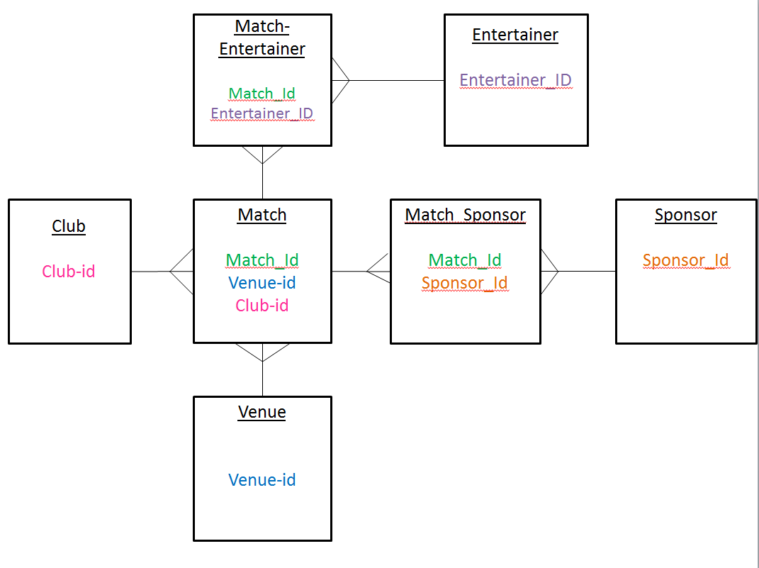

5.Extended ERD with table colume names

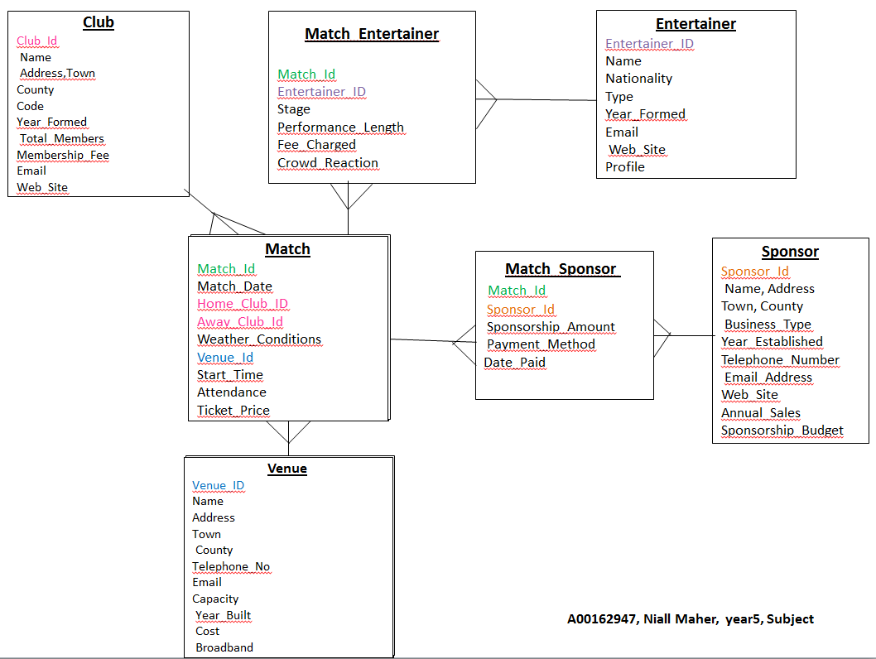

6.Create table statements

drop table Match_Sponsor ;
drop table Sponsor ;
drop table Match_Entertainer ;
drop table Entertainer ;
drop table Match ;
drop table Club ;
drop table Venue ;
drop table Venue ;

create table Venue (
Venue_ID Number (4),
Name Varchar2 (16),
Address Varchar2 (16),
Town Varchar2 (9),
County Varchar2 (9),
Telephone_No Varchar2 (14),
Email Varchar2 (41),
Capacity Number (5),
Year_Built Number (4),
Cost Number (5),
Broadband Varchar2 (3),
Constraint Venue_Venue_ID_Pk Primary Key (Venue_ID));

drop table Club ;
create table Club (
Club_Id Number (4),
Name Varchar2 (37),
Address Varchar2 (37),
Town Varchar2 (8),
County Varchar2 (6),
Code Varchar2 (9),
Year_Formed Number (4),
Total_Members Number (2),
Membership_Fee Number (3),
Email Varchar2 (38),
Web_Site Varchar2 (24),
Constraint Club_Club_id_Pk Primary Key (Club_id));

drop table Match ;
create table Match (
Match_Id Number (4),
Match_Date Date ,
Home_Club_ID Number (37),
Away_Club_Id Number (37),
Weather_Conditions Varchar2 (5),
Venue_Id Number (4),
Start_Time Number (3),
Attendance Number (5),
Ticket_Price Number (3),
Constraint Match_Match_Id_Pk Primary Key (Match_Id),
Constraint Match1_Fk Foreign Key (Home_Club_ID) References Club (Club_Id),
Constraint Match2_Fk Foreign Key (Away_Club_ID) References Club(Club_Id),
Constraint Venue_Fk Foreign Key(Venue_ID)References Venue(Venue_ID));

drop table Entertainer ;
create table Entertainer (
Entertainer_ID Number (4),
Name Varchar2 (9),
Nationality Varchar2 (7),
Type Varchar2 (10),
Year_Formed Number (5),
Email Varchar2 (24),
Web_Site Varchar2 (22),
Profile Varchar2 (20),
Constraint Entertainer_Entertainer_ID_Pk Primary Key(Entertainer_ID));

drop table Match_Entertainer ;
create table Match_Entertainer (
Match_Id Number (4),
Entertainer_ID Number (4),
Stage Varchar2 (28),
Performance_Length Number (4),
Fee_Charged Number (4),
Crowd_Reaction Varchar2 (9),
Constraint M_Entertainer_Pk Primary Key(Entertainer_ID,Match_Id),
Constraint M_Entertainer1_Fk Foreign Key(Match_Id) References Match(Match_Id),
Constraint M_Entertainer2_Fk Foreign Key(Entertainer_ID) References Entertainer(Entertainer_ID));

drop table Sponsor ;
create table Sponsor (
Sponsor_Id Number (4),
Address Varchar2 (14),
Town Varchar2 (11),
Business_Type Varchar2 (13),
Year_Established Number (6),
Telephone_Number Varchar2 (13),
Email_Address Varchar2 (18),
Web_Site Varchar2 (16),
Annual_Sales Number (5),
Sponsorship_Budget Number (6),
Constraint Sponsor_Sponsor_Id_Pk Primary Key(Sponsor_Id));

drop table Match_Sponsor ;
create table Match_Sponsor (
Match_Id Number (4),
Sponsor_Id Number (4),
Sponsorship_Amount Number (2),
Payment_Method Varchar2 (6),
Date_Paid Date ,
Constraint M_Sponsor_Pk Primary Key(Sponsor_Id,Match_Id),
Constraint M_Sponsor1_Fk Foreign Key(Match_Id) References Match(Match_Id),
Constraint M_sponsor2_Fk Foreign Key(Sponsor_Id) References Sponsor(Sponsor_Id));
7. Insert statements

/* Table Name:Venue */
/*Venue_ID,Name,Address, Town, County,Telephone_No,Email,Capacity ,Year_Built, Cost,Broadband */
Insert into Venue values (1001,'Riverside','90 Newpark Road','Birr','Offaly','353-120-12345','chairperson.galway@gaa.ie',20000,1901,2000,'yes');
Insert into Venue values (1002,'The Grange Kells','355 Cowper Road','Kells','Meath','353-120-1345','secretary.galway@gaa.ie',18000,1902,2500,'no');
Insert into Venue values (1003,'Riverside','189 Dunluce Road','Mullingar','Westmeath','353-120-9655','treasurer.galway@gaa.ie',17000,1903,3000,'yes');
Insert into Venue values (1004,'Ivy Leaf Grounds','53 Roberts Park','Dublin ','Dublin ','353-120-20655','Null',21000,1904,3500,'no');
Insert into Venue values (1005,'Riverside','172 Mill House','Moate','Westmeath','353-120-31655','pro.galway@gaa.ie',19500,1905,4000,'yes');
Insert into Venue values (1006,'Tymon Park','248 Castle Road','Birr','Offaly','353-120-42655','administrator.galway@gaa.ie',19700,1906,4500,'no');
Insert into Venue values (1007,'The Showgrounds ','161 Abbeyfield','Kells','Meath','353-120-53655','administrator1.galway@gaa.ie',19900,1907,5000,'yes');
Insert into Venue values (1008,'Riverside','523 Roberts Park','Mullingar','Westmeath','353-120-64655','youthofficer.galway@gaa.ie',20100,1908,5500,'no');
Insert into Venue values (1009,'Gallen','91 Newpark Road','Dublin ','Dublin ','353-120-75655','coachingofficer.galway@gaa.ie',20300,1909,6000,'yes');
Insert into Venue values (1010,'Riverside','356 Cowper Road','Moate','Westmeath','353-120-86655','Null',20500,1910,6500,'no');
Insert into Venue values (1011,'Park Lane','190 Dunluce Road','Birr','Offaly','353-120-97655','mseery@killu.com',45111,1911,7000,'yes');
Insert into Venue values (1012,'Riverside','172 Mill House','Kells','Meath','353-120-108655','secretary.hurling.galway@gaa.ie',52000,1912,7500,'no');
Insert into Venue values (1013,'Riverside','173 Mill House','Mullingar','Westmeath','353-120-119655','treasurer.hurling.galway@gaa.ie',21100,1913,8000,'yes');
Insert into Venue values (1014,'The Grange Kells','249 Castle Road','Dublin ','Dublin ','353-120-130655','secretary.annaghdown.galway@gaa.ie',21300,1914,8500,'no');
Insert into Venue values (1015,'Riverside','162 Abbeyfield','Moate','westmeath','353-120-141655','secretary.athenry.galway@gaa.ie',21500,1915,9000,'yes');
Insert into Venue values (1016,'Ivy Leaf Grounds','57 Roberts Park','Birr','Offaly','353-120-152655','secretary.abbeyknockmoy.galway@gaa.ie',45000,1916,9500,'no');
Insert into Venue values (1017,'Riverside','92 Newpark Road','Kells','Meath','353-120-163655','secretary.abbeyknockmoy.galway@gaa.ie',21900,1917,10000,'yes');
Insert into Venue values (1018,'Tymon Park','357 Cowper Road','Mullingar','Westmeath','353-120-174655','secretary.ahascraghfohenagh@gaa.ie',22100,1918,10500,'no');
Insert into Venue values (1019,'The Showgrounds ','191 Dunluce Road','Dublin ','Dublin ','353-120-185655','Null',65000,1919,11000,'yes');
Insert into Venue values (1020,'Riverside','523 Roberts Park','Moate','Westmeath','353-120-196655','secretary.anspideal.galway@gaa.ie',22500,1920,11500,'no');

/* Table Name:Club */
/* Club_Id,Name,Address,Town ,County,Code,Year_Formed, Total_Members ,Membership_Fee,Email,Web_Site */
Insert into Club values (2001,'Aurora Saracens Boys Rugby','Aurora Saracens Boys Rugby','Galway','Armagh','Soccer',1945,25,100,'colmloughran@btinternet.com','www.soccermad.com');
Insert into Club values (2002,'Boulder Valley Lions Boys Rugby','Boulder Valley Lions Boys Rugby','Cork','Armagh','Rugby',1946,31,200,'magherafelt@derry.gaa.ie','www.rugbycrazy.net');
Insert into Club values (2003,'Chaparral Wolverines Boys Rugby','Chaparral Wolverines Boys Rugby','Kerry','Carlow','Athletics',1947,48,100,'pkerrme@hotmail.co.uk','www.athleticsboaring.com');
Insert into Club values (2004,'Castle Rock Boys Rugby','Castle Rock Boys Rugby','Bray','Clare','Hockey',1948,51,200,'bmcmahon@hotmail.co.uk','www.hockeyknock.info');
Insert into Club values (2005,'Cherry Creek Boys Rugby','Cherry Creek Boys Rugby','Dublin','Clare','Hurling',1949,16,200,'roddymcivor@btinternet.com','www.stupidhurling.org');
Insert into Club values (2006,'Colorado Springs Grizzlies Boys Rugby','Colorado Springs Grizzlies Boys Rugby','Kildare','Clare','Football',1950,85,220,'n.murray@theprogressive.com','www.footballs.cc');
Insert into Club values (2007,'East HS Boys Rugby','East HS Boys Rugby','Kilkenny','Clare','Soccer',1951,21,240,'mariemcpeake@aol.com','www.soccermad.com');
Insert into Club values (2008,'Fort Collins Boys Rugby','Fort Collins Boys Rugby','Galway','Clare','Rugby',1952,34,260,'hughmcglone@btinternet.com','www.rugbycrazy.net');
Insert into Club values (2009,'Grand Junction / Junior Gents Rugby','Grand Junction / Junior Gents Rugby','Cork','Clare','Athletics',1953,29,280,'damien.mckane@seandolans.ie','www.athleticsboaring.com');
Insert into Club values (2010,'Legend / Ponderosa Boys Rugby','Legend / Ponderosa Boys Rugby','Kerry','Carlow','Hockey',1954,19,300,'darrenmcshane@jobcentreplus.gsi.gov.uk','www.hockeyknock.info');
Insert into Club values (2011,'Littleton Eagles Boys Rugby','Littleton Eagles Boys Rugby','Bray','Carlow','Hurling',1955,29,320,'darrenmcshane@jobcentreplus.gsi.gov.uk','www.stupidhurling.org');
Insert into Club values (2012,'Monument Hill Stormers','Monument Hill Stormers','Dublin','Carlow','Football',1956,36,340,'eamonmcneill@btinternet.com','www.footballs.cc');
Insert into Club values (2013,'Northside Vikings Rugby','Northside Vikings Rugby','Kildare','Carlow','Soccer',1957,68,360,'declan.lindsay1@btopenworld.co.uk','www.soccermad.com');
Insert into Club values (2014,'PAC Boys Rugby','PAC Boys Rugby','Kilkenny','Carlow','Rugby',1958,59,380,'andy@foyleside.co.uk','www.rugbycrazy.net');
Insert into Club values (2015,'Ranch Rugby Boys HS','Ranch Rugby Boys HS','Galway','Carlow','Athletics',1959,31,400,'sean.heraghty@bt.com','www.athleticsboaring.com');
Insert into Club values (2016,'Regis Jesuit Boys Rugby','Regis Jesuit Boys Rugby','Cork','Carlow','Hockey',1960,30,420,'ronan@caireland.org ','www.hockeyknock.info');
Insert into Club values (2017,'Ridgeview Academy Boys Rugby','Ridgeview Academy Boys Rugby','Kerry','Cavan','Hurling',1961,20,440,'Colin.McElroy@mater.n-i.nhs.uk','www.stupidhurling.org');
Insert into Club values (2018,'SWARM Boys Rugby','SWARM Boys Rugby','Bray','Cavan','Football',1962,18,460,'colummck@hotmail.com','www.footballs.cc');
Insert into Club values (2019,'Tigers RFC Boys Rugby','Tigers RFC Boys Rugby','Dublin','Cavan','Soccer',1963,37,480,'PaulandMaryJo@aol.com','www.soccermad.com');
Insert into Club values (2020,'Warrior RFC Boys Rugby','Warrior RFC Boys Rugby','Kildare','Cavan','Rugby',1964,26,500,'ulstergaagdm@btconnect.com','www.rugbycrazy.net');

/* Table Name:Match */
/*Match_Id,Match_Date,Home_Club_ID,Away_Club_Id,Weather_Conditions ,Venue_Id,Start_Time,Attendance,Ticket_Price */
Insert into Match values (3001,'01-Mar-92',2001,2020,'wet',1001,3.00,19700,50);
Insert into Match values (3002,'03-Apr-92',2002,2019,'dry',1002,4.00,17700,25);
Insert into Match values (3003,'06-May-92',2003,2018,'frost',1003,3.50,16700,50);
Insert into Match values (3004,'08-Jun-92',2004,2017,'snow',1004,3.30,20700,75);
Insert into Match values (3005,'11-Jul-92',2005,2016,'wet',1005,4.00,19200,50);
Insert into Match values (3006,'13-Aug-92',2006,2015,'dry',1006,4.30,19400,100);
Insert into Match values (3007,'15-Sep-92',2007,2014,'frost',1007,4.50,19600,125);
Insert into Match values (3008,'18-Oct-92',2008,2013,'snow',1008,2.30,19800,65);
Insert into Match values (3009,'20-Nov-92',2009,2012,'wet',1009,2.00,20000,80);
Insert into Match values (3010,'23-Dec-92',2010,2011,'dry',1010,1.00,20200,50);
Insert into Match values (3011,'25-Jan-93',2011,2010,'frost',1011,1.50,44811,150);
Insert into Match values (3012,'27-Feb-93',2012,2009,'snow',1012,1.30,51700,75);
Insert into Match values (3013,'01-Apr-93',2013,2008,'wet',1013,3.30,20800,100);
Insert into Match values (3014,'04-May-93',2014,2007,'dry',1014,5.00,21000,50);
Insert into Match values (3015,'06-Jun-93',2015,2006,'frost',1015,4.00,21200,20);
Insert into Match values (3016,'09-Jul-93',2016,2005,'snow',1016,1.30,44700,25);
Insert into Match values (3017,'11-Aug-93',2017,2004,'wet',1017,3.00,21600,90);
Insert into Match values (3018,'13-Sep-93',2018,2003,'dry',1018,4.00,21800,100);
Insert into Match values (3019,'16-Oct-93',2019,2002,'frost',1019,3.30,64700,50);
Insert into Match values (3020,'18-Nov-93',2020,2001,'snow',1020,2.30,22200,40);

/* Table Name:Entertainer */
/*Entertainer_ID,Name,Nationality,Type ,Year_Formed,Email,Web_Site,Profile */
Insert into Entertainer values (4001,'jim','Irish','Individual',1999,'madband@hotmail.com','www.madband.com','Unknown');
Insert into Entertainer values (4002,'john','English','Group',1989,'matchday@yahoo.com','www.matchday.info','National Profile');
Insert into Entertainer values (4003,'jo','French','Individual',1985,'needme@gmail.com','www.needenterainer.com','International Fame');
Insert into Entertainer values (4004,'joe','Germay','Group',1979,'freefun@ymail.com','www.freefun.org','Unknown');
Insert into Entertainer values (4005,'killy','Italyan','Individual',1990,'paddyforagoodtime@ait.ie','www.paddym.cc','National Profile');
Insert into Entertainer values (4006,'iris','Polish','Group',1852,'knockon@birr.rfc.ie','www.knockon.de','International Fame');
Insert into Entertainer values (4007,'liam','Russian','Individual',1852,'madband@hotmail.com','www.madband.com','Unknown');
Insert into Entertainer values (4008,'paddy ','Irish','Group',1999,'matchday@yahoo.com','www.matchday.info','National Profile');
Insert into Entertainer values (4009,'reece','English','Individual',1998,'needme@gmail.com','www.needenterainer.com','International Fame');
Insert into Entertainer values (4010,'leigh','French','Group',1996,'freefun@ymail.com','www.freefun.org','Unknown');
Insert into Entertainer values (4011,'nicky','Germay','Individual',1987,'paddyforagoodtime@ait.ie','www.paddym.cc','National Profile');
Insert into Entertainer values (4012,'danny','Italyan','Group',1870,'knockon@birr.rfc.ie','www.knockon.de','International Fame');
Insert into Entertainer values (4013,'frerdy','Polish','Individual',2000,'madband@hotmail.com','www.madband.com','Unknown');
Insert into Entertainer values (4014,'frostie','Russian','Group',2001,'matchday@yahoo.com','www.matchday.info','National Profile');
Insert into Entertainer values (4015,'francies','Irish','Individual',2010,'needme@gmail.com','www.needenterainer.com','International Fame');
Insert into Entertainer values (4016,'fredo','English','Group',2012,'freefun@ymail.com','www.freefun.org','Unknown');
Insert into Entertainer values (4017,'jump','French','Individual',2015,'paddyforagoodtime@ait.ie','www.paddym.cc','National Profile');
Insert into Entertainer values (4018,'hillstart','Germay','Group',1996,'knockon@birr.rfc.ie','www.knockon.de','International Fame');
Insert into Entertainer values (4019,'gunner','Italyan','Individual',1993,'madband@hotmail.com','www.madband.com','Unknown');
Insert into Entertainer values (4020,'last shot','Polish','Group',1893,'matchday@yahoo.com','www.matchday.info','Unknown');

/* Table Name:Match_Entertainer */
/*Match_Id,Entertainer_ID,Stage ,Performance_Length,Fee_Charged ,Crowd_Reaction */
Insert into Match_Entertainer values (3001,4001,'Before ',24,1000,'Poor');
Insert into Match_Entertainer values (3002,4002,'Half time',28,3000,'Good');
Insert into Match_Entertainer values (3003,4003,'After the match has finished',33,5000,'Excellent');
Insert into Match_Entertainer values (3004,4004,'Before ',25,1000,'Poor');
Insert into Match_Entertainer values (3005,4005,'Half time',45,3000,'Good');
Insert into Match_Entertainer values (3006,4006,'After the match has finished',42.7,5000,'Excellent');
Insert into Match_Entertainer values (3007,4007,'Before ',46.6,1000,'Poor');
Insert into Match_Entertainer values (3008,4008,'Half time',50.5,3000,'Good');
Insert into Match_Entertainer values (3009,4009,'After the match has finished',54.4,5000,'Excellent');
Insert into Match_Entertainer values (3010,4010,'Before ',58.3,1000,'Poor');
Insert into Match_Entertainer values (3011,4011,'Half time',62.2,3000,'Good');
Insert into Match_Entertainer values (3012,4012,'After the match has finished',66.1,5000,'Good');
Insert into Match_Entertainer values (3013,4013,'Before ',96,1000,'Poor');
Insert into Match_Entertainer values (3014,4014,'Half time',52,3000,'Good');
Insert into Match_Entertainer values (3015,4015,'After the match has finished',21,5000,'Excellent');
Insert into Match_Entertainer values (3016,4016,'Before ',21,1000,'Poor');
Insert into Match_Entertainer values (3017,4017,'Half time',60,3000,'Good');
Insert into Match_Entertainer values (3018,4018,'After the match has finished',74,5000,'Excellent');
Insert into Match_Entertainer values (3019,4019,'Before ',55,1000,'Poor');
Insert into Match_Entertainer values (3020,4020,'Half time',65,3000,'Good');

/* Table Name:Match_Sponsor */
/*Match_Id, Sponsor_Id, Sponsorship_Amount, Payment_Method , Date_Paid */
Insert into Match_Sponsor values (3001,5001,17,'Cash','01-Mar-92');
Insert into Match_Sponsor values (3002,5002,12,'Cheque','03-Apr-92');
Insert into Match_Sponsor values (3003,5003,14,'EFT ','06-May-92');
Insert into Match_Sponsor values (3004,5004,55,'Cash','08-Jun-92');
Insert into Match_Sponsor values (3005,5005,7,'Cheque','11-Jul-92');
Insert into Match_Sponsor values (3006,5006,35,'EFT ','13-Aug-92');
Insert into Match_Sponsor values (3007,5007,4,'Cash','15-Sep-92');
Insert into Match_Sponsor values (3008,5008,2,'Cheque','18-Oct-92');
Insert into Match_Sponsor values (3009,5009,3,'EFT ','20-Nov-92');
Insert into Match_Sponsor values (3010,5010,2,'Cash','23-Dec-92');
Insert into Match_Sponsor values (3011,5011,14,'Cheque','25-Jan-93');
Insert into Match_Sponsor values (3012,5012,3,'EFT ','27-Feb-93');
Insert into Match_Sponsor values (3013,5013,4,'Cash','01-Apr-93');
Insert into Match_Sponsor values (3014,5014,5,'Cheque','04-May-93');
Insert into Match_Sponsor values (3015,5015,6,'EFT ','06-Jun-93');
Insert into Match_Sponsor values (3016,5016,7,'Cash','09-Jul-93');
Insert into Match_Sponsor values (3017,5017,8,'Cheque','11-Aug-93');
Insert into Match_Sponsor values (3018,5018,9,'EFT ','13-Sep-93');
Insert into Match_Sponsor values (3019,5019,10,'Cash','16-Oct-93');
Insert into Match_Sponsor values (3020,5020,11,'Cash','18-Nov-93');

/* Table Name:Sponsor */
/* Sponsor_Id,Address,Town,Business_Type ,Year_Established ,Telephone_Number, Email_Address,Web_Site ,Annual_Sales,Sponsorship_Budget */
Insert into Sponsor values (5001,'12fstreet','Birr','Manufacturing',1990,'353-159-12369','birr@inof','fun.com',10000,34400);
Insert into Sponsor values (5002,'45roundabout','Tullamore','Finance',1991,'353-160-12371','runroad.vcom','happyhour.cc',11000,26702);
Insert into Sponsor values (5003,'67hillroad','Killcormuck','Grocery',1992,'353-159-12373','bigbucks.org','likeme.com',9200,19004);
Insert into Sponsor values (5004,'65gunrun','Drum','Public House ',1993,'Null','jim.cc','iknowu.de',9000,11306);
Insert into Sponsor values (5005,'54caveview','Gelnbarrow','Manufacturing',1994,'353-159-12370','liveinacave.de','funtimes.com',8000,3608);
Insert into Sponsor values (5006,'12fstreet','Green hill','Finance',1995,'353-160-12372','birr@inof','sponsor.ie',5000,111380);
Insert into Sponsor values (5007,'45roundabout','Birr','Grocery',1996,'353-159-12374','runroad.vcom','fun.com',12000,103682);
Insert into Sponsor values (5008,'67hillroad','Tullamore','Public House ',1997,'Null','bigbucks.org','happyhour.cc',10000,95984);
Insert into Sponsor values (5009,'65gunrun','Killcormuck','Manufacturing',1998,'353-159-12371','jim.cc','likeme.com',20000,88286);
Insert into Sponsor values (5010,'54caveview','Drum','Finance',1999,'353-160-12373','liveinacave.de','iknowu.de',25000,80588);
Insert into Sponsor values (5011,'12fstreet','Gelnbarrow','Grocery',2000,'353-159-12375','birr@inof','funtimes.com',15000,72890);
Insert into Sponsor values (5012,'45roundabout','Green hill','Public House ',2001,'Null','runroad.vcom','sponsor.ie',12365,65192);
Insert into Sponsor values (5013,'67hillroad','Birr','Manufacturing',2002,'353-159-12372','bigbucks.org','fun.com',12000,57494);
Insert into Sponsor values (5014,'65gunrun','Tullamore','Finance',2003,'353-160-12374','jim.cc','happyhour.cc',10000,49796);
Insert into Sponsor values (5015,'54caveview','Killcormuck','Grocery',2004,'353-159-12376','liveinacave.de','likeme.com',6000,42098);
Insert into Sponsor values (5016,'12fstreet','Drum','Public House ',2005,'Null','birr@inof','iknowu.de',52000,34400);
Insert into Sponsor values (5017,'45roundabout','Gelnbarrow','Manufacturing',2006,'353-159-12373','runroad.vcom','funtimes.com',3000,26702);
Insert into Sponsor values (5018,'67hillroad','Green hill','Finance',2007,'353-160-12375','bigbucks.org','sponsor.ie',20000,19004);
Insert into Sponsor values (5019,'65gunrun','Birr','Grocery',2008,'353-159-12377','jim.cc','fun.com',10020,11306);
Insert into Sponsor values (5020,'54caveview','Tullamore','Public House ',2009,'Null','liveinacave.de','happyhour.cc',10000,3608);

Select * from Venue;
Select * from Club;
Select * from Match;
Select * from Entertainer;
Select * from Match_Entertainer;
Select * from Sponsor;
Select * from Match_Sponsor;

8.Tables
Venue

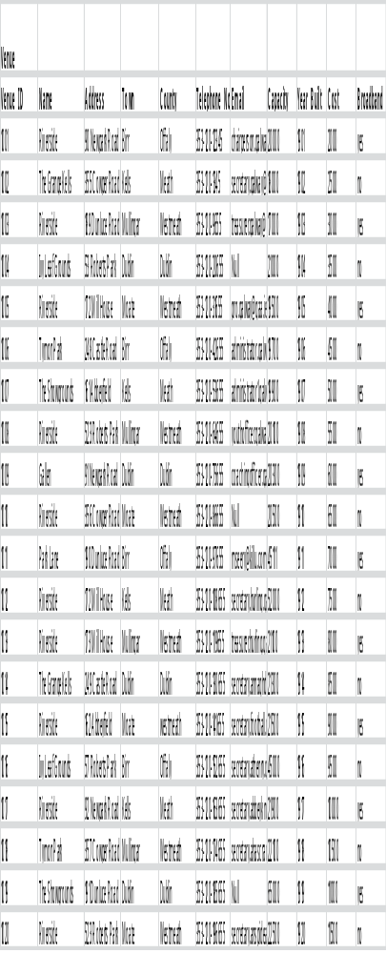
Club

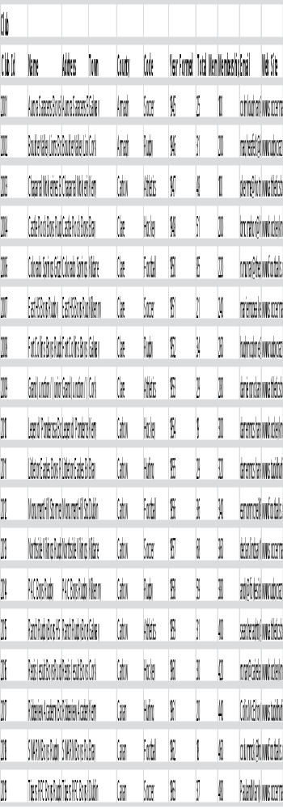

Match

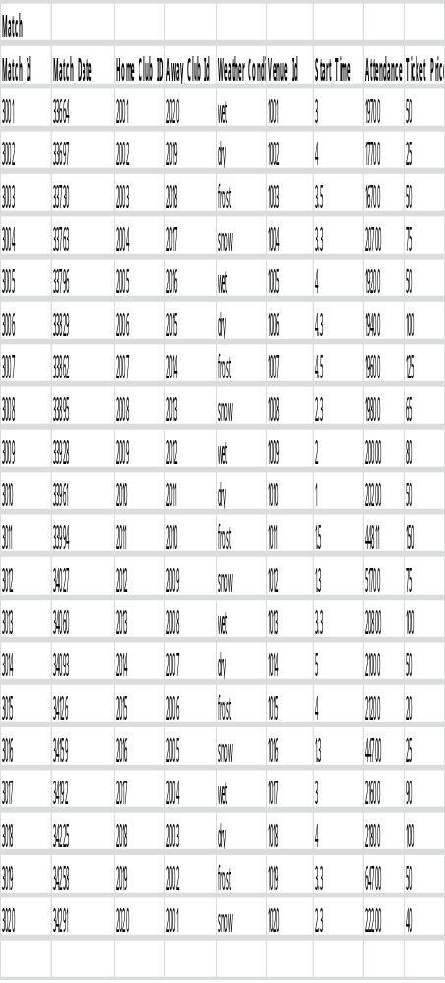
Entertainer

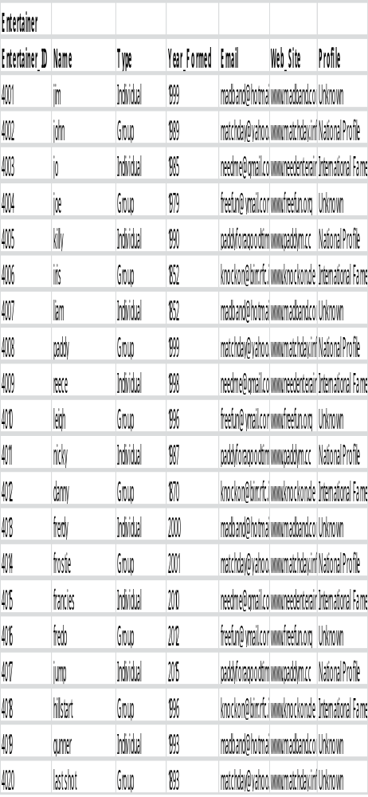
Match_ Entertainer

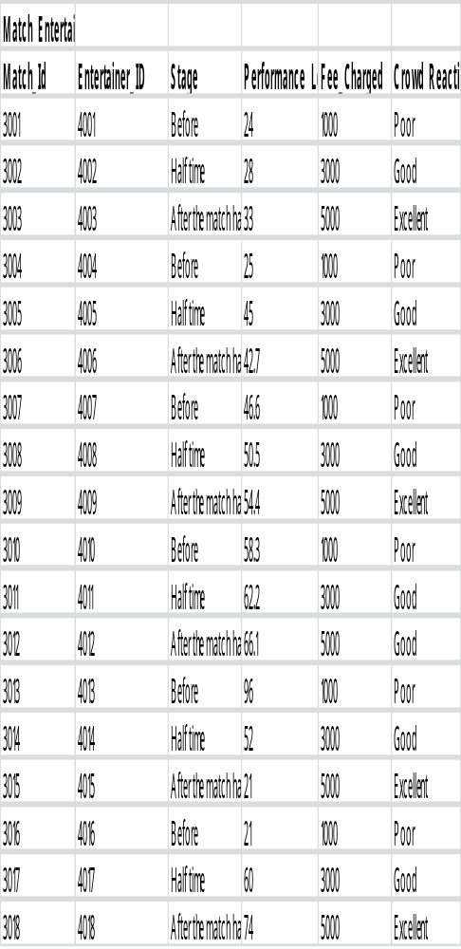
Sponsor

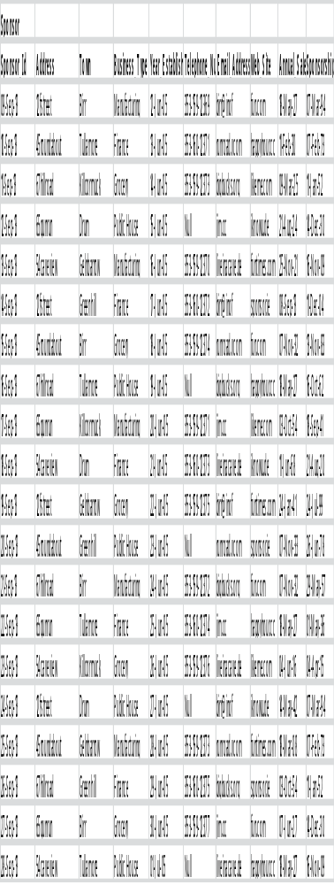
Match_Sponsor

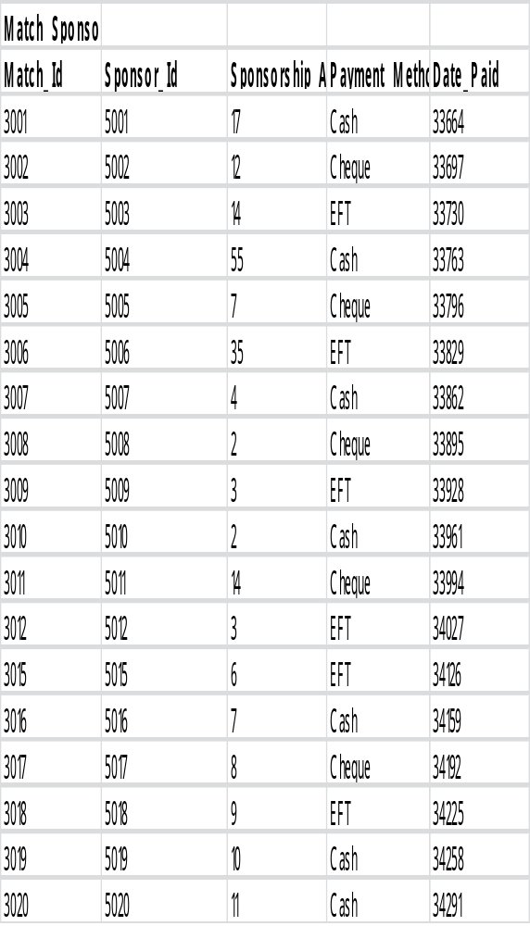

9.Single Table Queries

-- Big Match Entertainment-BME – Niall Maher Year: 2012-2013

--Big Match Entertainment-BME Section 1 Oracle Projects -BME– Single Table Queries

Spool C:\Clare\STQ.txt

/* Q1
Give the ID,Name,Town,County,Broadband,Cost of all venues that the town is not in birr and have broadband or list the venue that cost less then 3000 */

/* Standard Solution */
Set Linesize 200

Select Venue_ID,Name,Address,Town,County,Telephone_No,Email,Capacity ,Year_Built,Cost,Broadband
From Venue
Where Town <> ‘Birr’
And Broadband=’yes’
Or Cost>3000;

Select Venue.Venue_ID,Venue.Name,Venue.Address,Venue.Town,Venue.County, Venue.Telephone_No, Venue.Email, Venue.Capacity, Venue.Year_Built,Venue.Cost,Venue.Broadband
From Venue
Where Venue.Town <> ‘Birr’
And Venue.Broadband=’yes’
Or Venue.Cost>3000;

Select V.Venue_ID,V.Name,V.Address,V.Town,V.County, V.Telephone_No, V.Email, V.Capacity, V.Year_Built,V.Cost,V.Broadband
From Venue V
Where V.Town <> ‘Birr’
And V.Broadband=’yes’
Or V.Cost>3000;

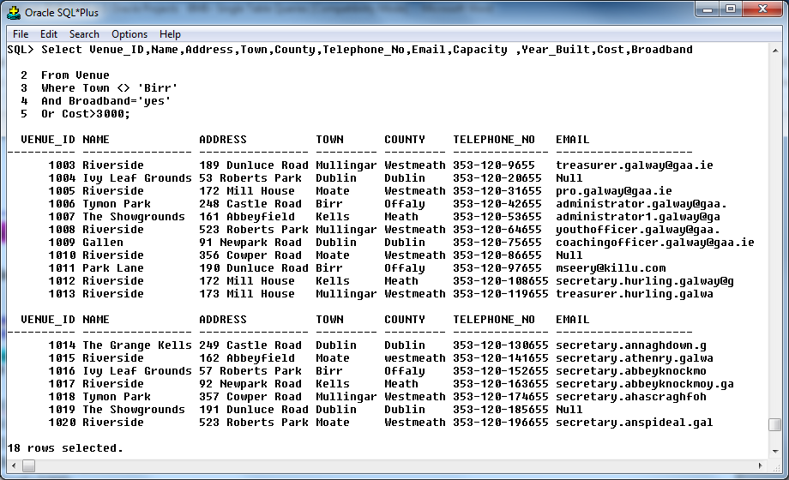

/* Q2
Give the name, Address,Town, and Code of those Clubs who have the letter a in there name ,an Code = ‘Rugby’. Exclude Clubs that year formed is less than 1950 . Arrange the results in reverse alphabetical order by name */

/* Standard Solution */

Select Club_Id,Name,Address,Town,County,Code,Year_Formed
From Club
Where Name Like ‘%a%’
And Code=’Rugby’
And Year_Formed >1950
Order by Name DESC;

Select Club.Club_Id, Club.Name,Club.Address,Club.Town,Club.County,Club.Code, Club.Year_Formed
From Club
Where Club.Name Like ‘%a%’
And Club.Code=’Rugby’
And Club.Year_Formed >1950
Order by Name DESC;

Select C.Club_Id, C.Name,C.Address,C.Town,C.County,C.Code, C.Year_Formed
From Club C
Where C.Name Like ‘%a%’
And C.Code=’Rugby’
And C.Year_Formed >1950
Order by Name DESC;

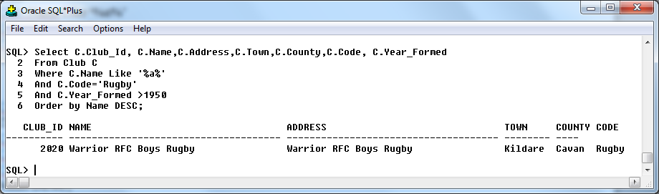

/* Q3
List the Match_Date, details ,Weather_Conditions, fee, Attendance, Eliminate Match details that ticket price is Less than 50, And the Attendance is not between 20000 and 22000,Also Eliminate the matches that start at4.00 */

Select Match_Id,Match_Date,Home_Club_ID,Away_Club_Id,Weather_Conditions ,Venue_Id,Start_Time,Attendance,Ticket_Price
From Match
Where Ticket_Price>50
And Attendance BETWEEN 20000 AND 22000
And Start_Time<>4.00;

Select Match.Match_Id,Match.Match_Date,Match.Home_Club_ID,Match.Away_Club_Id, Match.Weather_Conditions,Match.Venue_Id,Match.Start_Time,Match.Attendance, Match.Ticket_Price
From Match
Where Match.Ticket_Price>50
And Match.Attendance BETWEEN 20000 AND 22000
And Match.Start_Time<>4.00;

Select M.Match_Id,M.Match_Date,M.Home_Club_ID,M.Away_Club_Id, M.Weather_Conditions,M.Venue_Id,M.Start_Time,M.Attendance, M.Ticket_Price
From Match M
Where M.Ticket_Price>50
And M.Attendance BETWEEN 20000 AND 22000
And M.Start_Time<>4.00;

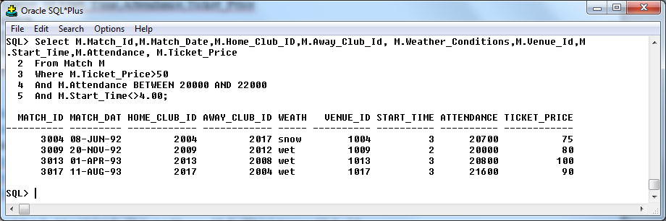

/* Q4
Show the name,Nationality,Type,Year_Formed,Email,Web_Site, And the profile for Entertainer that Nationality is Not Irish and have a profile that is Unknown. Organise the results in ascending order by Name */

Select Entertainer_ID,Name,Nationality,Type,Year_Formed,Email,Web_Site,Profile
From ENTERTAINER
Where Nationality !=’Irish’
And Profile=’Unknown’
Order By Name ASC;

Select Entertainer.Entertainer_ID, Entertainer.Name, Entertainer.Nationality, Entertainer.Type, Entertainer.Year_Formed, Entertainer.Email, Entertainer.Web_Site, Entertainer.Profile
From ENTERTAINER
Where Entertainer.Nationality !=’Irish’
And Entertainer.Profile=’Unknown’
Order By Name ASC;

Select E.Entertainer_ID, E.Name, E.Nationality, E.Type, E.Year_Formed, E.Email, E.Web_Site
From ENTERTAINER E
Where E.Nationality !=’Irish’
And E.Profile=’Unknown’
Order By Name ASC;

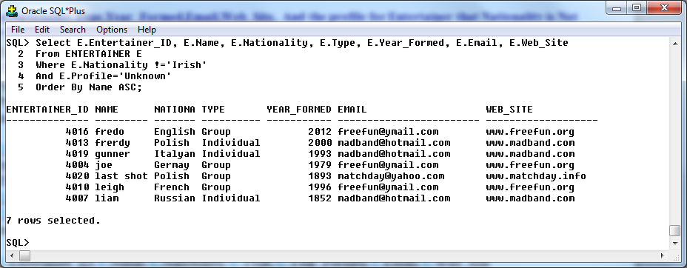

/* Q5
Give the Match_Id,Entertainer_ID,Stage ,Performance_Length,Fee_Charged ,Crowd_Reaction, Confine the output to Match_Entertainer that have a Performance_Length Between 43 and 70 and stage is halftime and where the fee charged is not equal to 1000. */

Select Match_Id,Entertainer_ID,Stage ,Performance_Length,Fee_Charged ,Crowd_Reaction
From Match_Entertainer
Where Stage=’Half time’
And Performance_Length BETWEEN 43 AND 70
And Fee_Charged !=1000;

Select Match_Entertainer.Match_Id, Match_Entertainer.Entertainer_ID, Match_Entertainer.Stage , Match_Entertainer.Performance_Length, Match_Entertainer.Fee_Charged , Match_Entertainer.Crowd_Reaction
From Match_Entertainer
Where Match_Entertainer.Stage=’Half time’
And Match_Entertainer.Performance_Length BETWEEN 43 AND 70
And Match_Entertainer.Fee_Charged !=1000;

Select ME.Match_Id, ME.Entertainer_ID, ME.Stage , ME.Performance_Length, ME.Fee_Charged ,ME.Crowd_Reaction
From Match_Entertainer ME
Where ME.Stage=’Half time’
And ME.Performance_Length BETWEEN 43 AND 70
And ME.Fee_Charged !=1000;

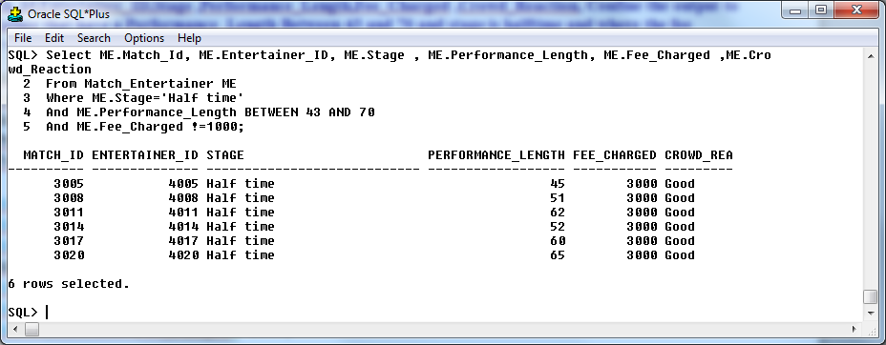

Spool Off

10.Queries involving joins

-- Big Match Entertainment-BME – Niall Maher Year: 2012-2013

--Big Match Entertainment-BME 3 Oracle Projects Section 2 Oracle Projects - Joins

Spool C:\Clear\Joins.txt

/* Q1 (Joins) PCQ (Parent Child Query involving 2 related tables – must involve PK = FK in the join condition)
(See Parent Child Joins (PCQ) on page 11-12 of Demobld Notes on Moodle for examples and explanations) */

Select M.Match_Id,M.Match_Date,M.Home_Club_ID,M.Away_Club_Id, M.Venue_Id,M.Weather_Conditions,M.Venue_Id, V.Venue_ID,V.Name,V.Address,V.Town,V.County
From Match M, Venue V
Where M.Venue_ID = V.Venue_ID
And M.Ticket_Price>50
And V.Town <> ‘Birr’
And M.Start_Time<>4.00;
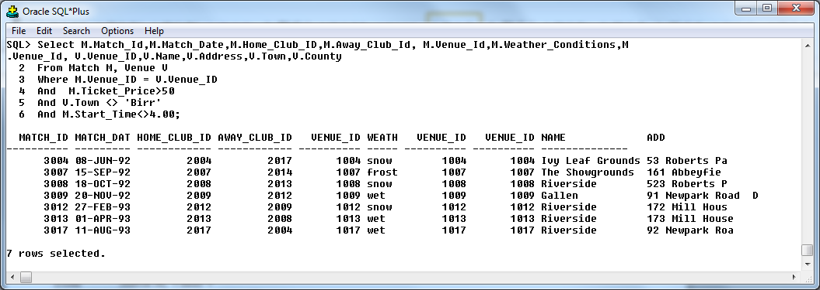

/* Q2 (Joins PCQ -Parent Child Query involving 3 related tables – ie PK = FK comparisons in the join) */

Select C.Club_Id, C.Name,C.Address,C.Code,
M.Match_Id,M.Match_Date,M.Home_Club_ID,M.Away_Club_Id, M.Venue_Id
From Club C, Match M
Where M.Home_Club_ID = C.Club_Id
And C.Code=’Rugby’
And M.Ticket_Price<50;
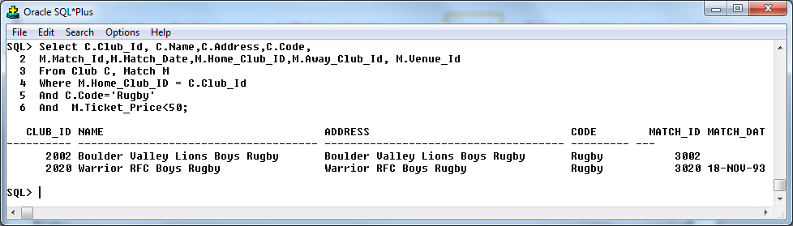

/* Q3 PCQ (Parent Child Query involving ALL tables – 8 tables in this case – PK = FK comparisons in each join condition) */

Select ME.Match_Id, ME.Entertainer_ID, ME.Fee_Charged ,ME.Crowd_Reaction ,ME.Stage , ME.Fee_Charged ,E.Entertainer_ID, E.Name, E.Nationality, E.Type
From Match_Entertainer ME, ENTERTAINER E
Where E. Entertainer_ID= ME.Entertainer_ID
And E. Type != ‘Group’
And ME.Fee_Charged = 3000;
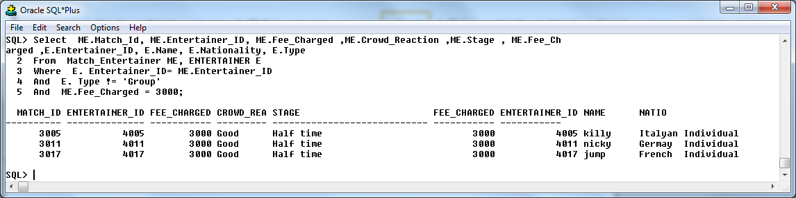

/* Q4 Other Equi Join (OEJ) - two tables that arent linked via a PK = FK
(See Other Equi Joins (OEJ) on page 13 of Demobld Notes on Moodle for examples and explanations) */

Select ME.Match_Id, ME.Entertainer_ID,M.Match_Id,M.Away_Club_Id, M.Weather_Conditions,M.Venue_Id
From Match M, Match_Entertainer ME
Where ME.Match_Id = M.Match_Id
And M.Venue_Id>1005
And M.Weather_Conditions = ‘snow’;

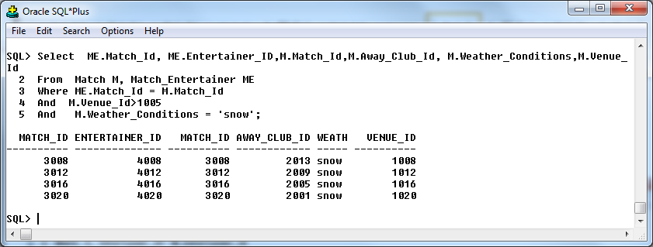

/* Q5
An Equijoin (ie "Other Equi Join") based on two different tables to previous query that arent linked via a PK = FK
(See Other Equi Joins (OEJ) on page 13 of Demobld Notes on Moodle for examples and explanations) */

Select S.Sponsor_Id, S.Address, S.Town, S.Business_Type, MS.Match_Id, MS.Sponsor_Id, MS.Sponsorship_Amount
From Sponsor S, Match_Sponsor MS
Where S.Sponsor_Id= MS.Sponsor_Id
And S.Business_Type <>’Finance’
And MS.Match_Id >3007;

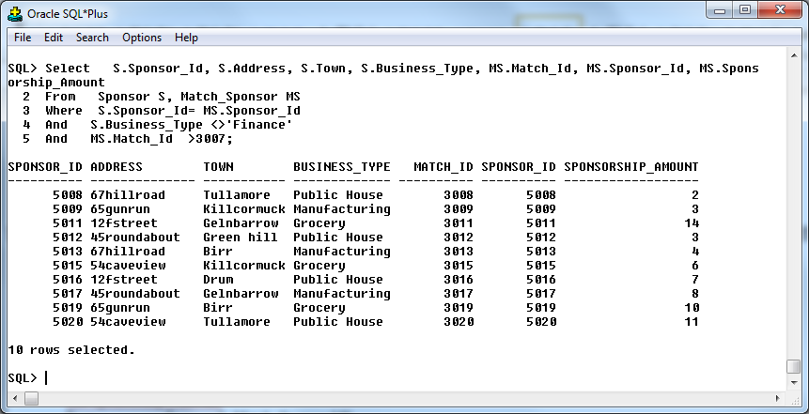

/* Q6
An Non-Equijoin based on any two tables (ie the query must use either > or < in the join condition) (See Non Equi Joins on page 13 of Demobld Notes on Moodle for examples and explanations) */

Select MS.Match_Id, MS.Sponsor_Id, MS.Sponsorship_Amount, M.Match_Id,M.Match_Date,M.Attendance,M.Weather_Conditions
From Match_Sponsor MS , Match M
Where M.Match_Id = MS.Match_Id
And M.Attendance <30000
And M.Weather_Conditions = ‘wet’;

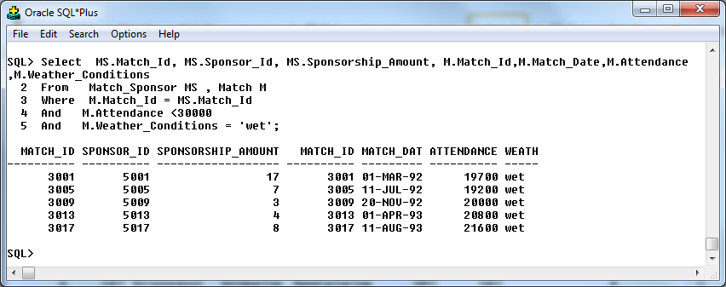

/* Q7
An Non-Equijoin based on any two different tables to the previous query*/

Select M.Match_Id,M.Match_Date,M.Attendance,M.Weather_Conditions ,C.Club_Id, C.Name,C.Address,C.Town
From Club C , Match M
Where M.Match_Id <> C.Club_Id
And M.Attendance <30000
And M.Weather_Conditions = ‘wet’
And M.Match_Id<3002;

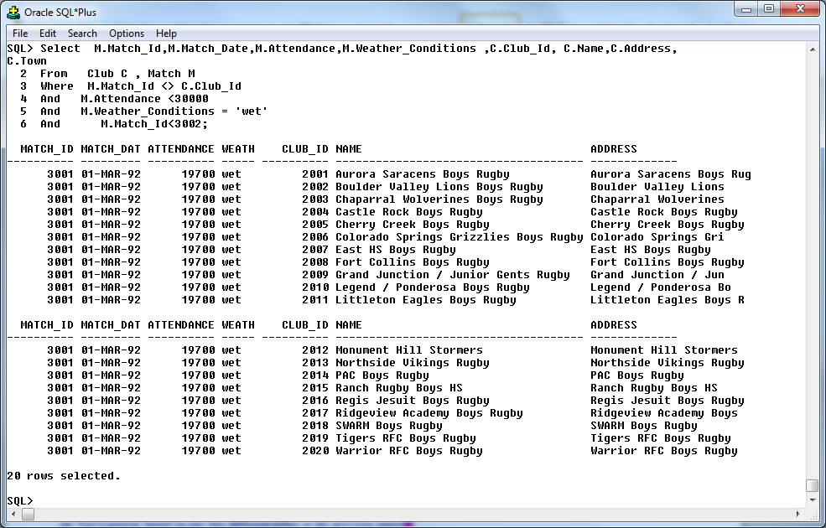

SPOOL OFF

11. Summary queries

-- Big Match Entertainment-BME – Niall Maher Year: 2012-2013

--Big Match Entertainment-BME 3 Oracle Projects - Summary Queries

Spool C:\Clear\SumQ.txt

/*Q1
Query that uses at least one of Max, Min, Sum, Avg, Count in the SELECT clause - copy and edit to demonstrate TABLE aliases*/

Select Avg(V.Capacity)
From Venue V;

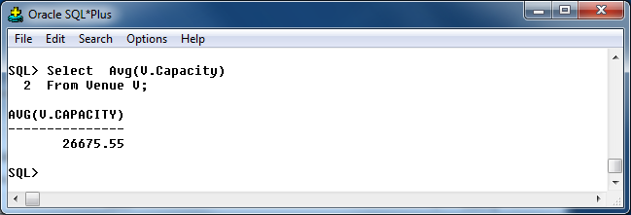

/*2 Query (on a different table to query 1) that uses at least FOUR of Max, Min, Sum, Avg, Count in the SELECT clause - copy and edit to demonstrate QUALIFIED COLUMN Names*/

Select Min(V.Cost),Max(V.Cost),Sum(V.Cost),Avg(V.Cost),Count(V.Cost)
From Venue V;

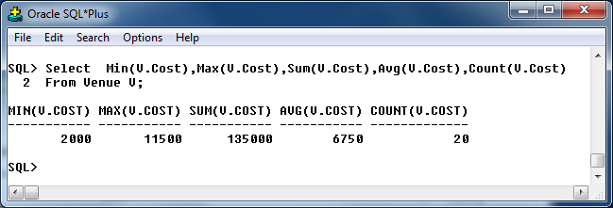

/* Q3 Query That Uses Count(*) Function And Count(Ename) Or Some Other Column In The SELECT Clause - Copy And Edit To Demonstrate TABLE Aliases*/

Select Count(C.Code)
From Club C
Where C.Code Is NOT NULL;

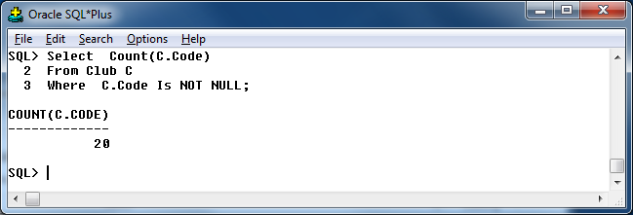

/* Q4 Query that uses at least one of Max, Min, Sum, Avg, Count in the SELECT clause along with NULL in the where clause*/

Select Avg(M.Attendance)
From Match M
Where M.Attendance Is NOT NULL;

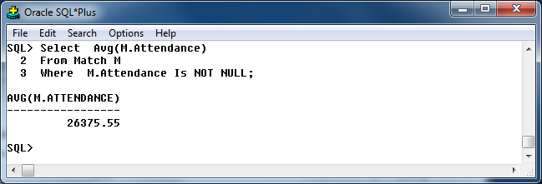

/* 5 Query that does a calculation in the Select clause and also illustrates column aliases eg Select Max(Sal) - Min(Sal) "Salary Range"*/

Select Max(M.Ticket_Price),Min(M.Ticket_Price),Max(M.Ticket_Price)-Min(M.Ticket_Price) “Difference in max and min”
From Match M;

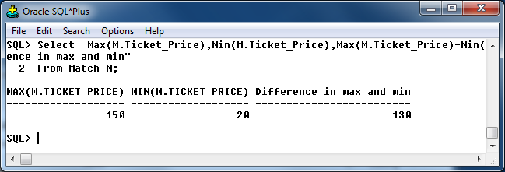

/*Q6 Group By query uses at least one of Max, Min, Sum, Avg, Count in the SELECT clause - copy and edit to demonstrate TABLE aliases */

Select ME.Entertainer_Id,Min(Fee_Charged),Max(Fee_Charged)
From Match_Entertainer ME
Group By ME.Entertainer_id;

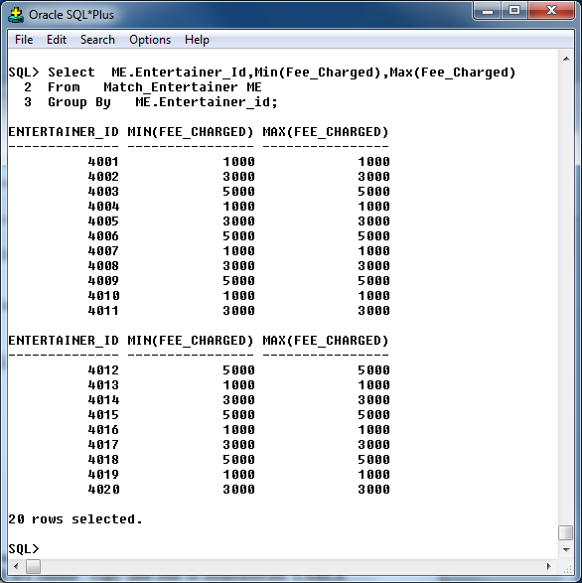

/*Q7 Group By query (on a diff table to Q6) that uses at least three of Max, Min, Sum, Avg, Count in the SELECT clause -query must also include a WHERE clause and an ORDER BY clause - copy and edit to demonstrate TABLE aliases */

Select Min(V.Cost),Max(V.Cost),Sum(V.Cost),Avg(V.Cost),Count(V.Cost)
From Venue V
Order by Min(V.Cost) Desc ;

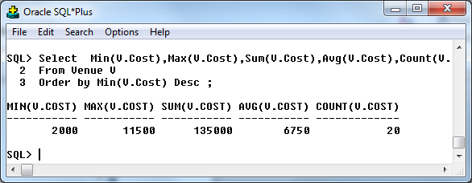

/*Q8 Group By query (that requires a of at least two tables) that uses at least one of Max, Min, Sum, Avg, Count in the SELECT clause - copy and edit to demonstrate TABLE aliases*/

Select S.Business_Type,Max(S.Annual_Sales),Avg(S.Annual_Sales),Min(S.Annual_Sales)
From Sponsor S
Where S.Business_Type = ‘Grocery’
Group by S.Business_Type
Order by Max(S.Annual_Sales) Desc;

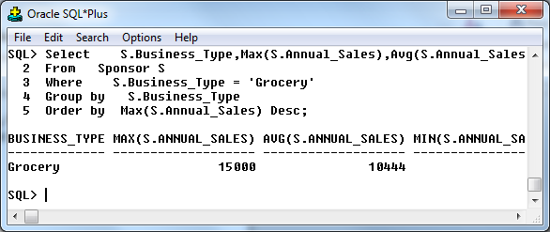

/*Q9 Group By query (on a diff table to Q6) that uses at least three of Max, Min, Sum, Avg, Count in the SELECT clause -query should also include a WHERE clause and an ORDER BY clause - copy and edit to demonstrate TABLE aliases. */

Select V.Name,Max(M.Ticket_Price),Min(M.Ticket_Price)
From Venue V,Match M
Where V.Venue_ID=M.Venue_Id
Group by V.Name;

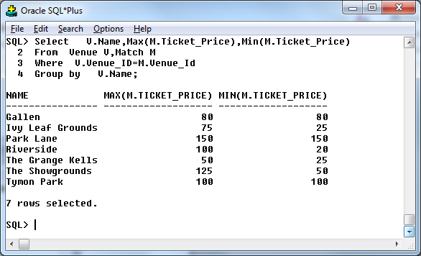

/*Q 10 Group By query that includes a HAVING clause and has at least one of Max, Min, Sum, Avg, Count in the SELECT clause - copy and edit to demonstrate TABLE aliases*/

Select C.Town,Count(*)
From Club C
Group by C.Town
Having Count(*)!=3;

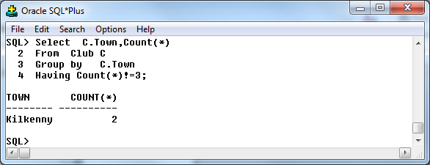

SPOOL OFF

12. Subqueries

-- Big Match Entertainment-BME – Niall Maher Year: 2012-2013

Big Match Entertainment-BME -BME– Section 4 Oracle Projects - Subqueries

Spool C:\Clear\SubQ.txt

/* Q 1 Simple Subquery where same table is used in Main and Subquery (and the inner query uses one of Max,Min,Sum,Avg,Count) eg Name the employee(s) on largest salary; Name the customer on the biggest credit limit-ie inner query uses one of Max,Min,Sum,Avg,Count and generates one row of output.

List the Match_Date,Weather_Conditions, and Attendance of the match with the largest Attendance.

Select Match_Id,Weather_Conditions,Attendance
From Match
Where Attendance=
(Select Max(Attendance)
From Match);

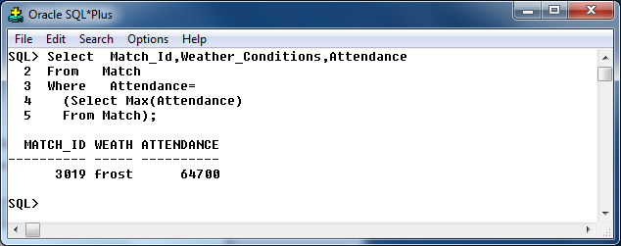

/* Q 2 SQ with extra conditions in the WHERE clause that uses the MAX or MIN function with a NUMBER - eg Name those employees who work as ANALYSTS that earn more than the best paid clerk.

List the Match_Id,Weather_Conditions,Attendance And Attendance of the most Attendanced match (type column) Match.'

Select Match_Id,Weather_Conditions,Attendance
From Match
Where Weather_Conditions = ‘wet’
And Attendance=
(Select Max(Attendance)
From Match
Where Weather_Conditions = ‘wet’);

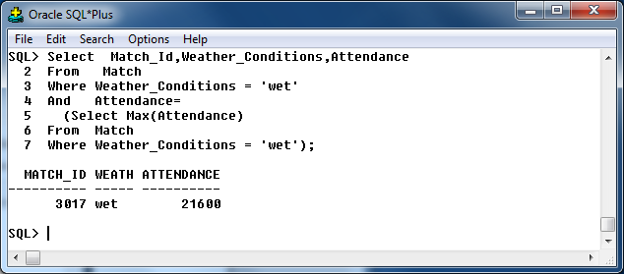

/* Q 3 SQ using AVG and one of the > or < operator in inner query - eg name those employees who earn more than the average salary. */

Give the Entertainer_ID,Stage,Crowd_Reaction,Fee_Charged for those Crowd_Reaction that are ‘Good’ that have a fee in excess of the average fee for appointments paid by ‘Poor.'

Select Entertainer_ID,Stage,Crowd_Reaction,Fee_Charged
From Match_Entertainer
Where Crowd_Reaction = 'Good'
And Fee_Charged>
(Select Avg(Fee_Charged)
From Match_Entertainer
Where Crowd_Reaction = 'Poor');

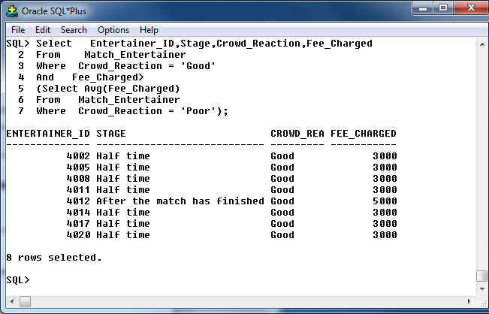

/* Q 4 IN Clause in a situation where the same table is used in both the main query and the subquery - eg Give the name, job, and sal of employees that were hired before the 31st Dec 1980 that have a job title similar to employees hired after Oct 1st 1981. In this case a Varchar or Date column is used in the comparison-ie Job or Hiredate. */

Show the Name,County,Code of those clubs from ‘Clare’ (town colum) that have the same code as the Club based in ‘Carlow’..

Select Name,County,Code
From Club
Where County =’Clare’
And Code In
(Select Code
From Club
Where County =’Carlow’);

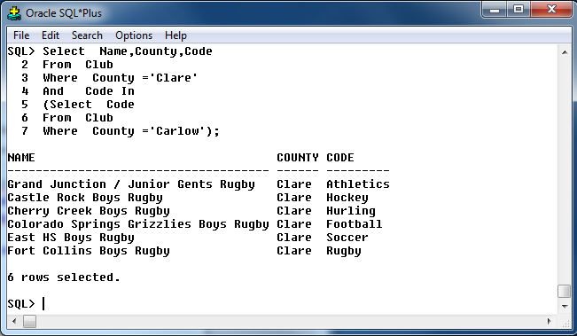

/* Q 5 Use of IN as a means of "linking" at least 2 diff tables in Main query and inner query - ie usually a situation involving a PK and an FK as the "linking" column. Either the Parent or the child table will feature in the main (outer) query, the other table in the inner query. eg1 Give the names of departments that employ staff earning more than 2000. eg2 Name the employees who work in the Accounting department.
Hint for previous query - Test inner query to ensure that it returns > 1 row of data. Otherwise its pointless using the IN operator! */

Show the Name,County,Code,Club_id of those clubs from ‘Clare’ (town colum) that Weather_Conditions are either ‘wet’or ‘dry’

Select Name,County,Code,Club_id
From Club
Where County =’Clare’
And Club.Club_id In
(Select Match.Home_Club_ID
From Match
Where Weather_Conditions In (‘wet’, ‘dry’));

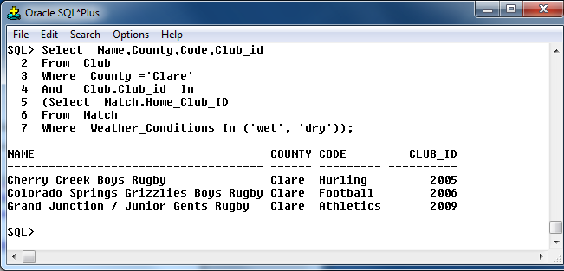

/* Q 6 Repeat the bulk of the query above - but change the wording so that NOT IN can be used on this occasion as the link between the OUTER and INNER queries. */

.Show the Name,County,Code,Club_id of those clubs from ‘Clare’ (town colum) that Weather_Conditions are either ‘wet’or ‘dry’

Select Name,County,Code,Club_id
From Club
Where County =’Clare’
And Club.Club_id Not In
(Select Match.Home_Club_ID
From Match
Where Weather_Conditions In (‘wet’, ‘dry’));

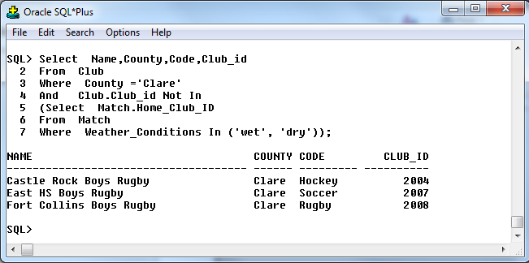

/* Q 7 Use of IN as a means of "linking" at least 3 diff tables in Main query and inner query - ie usually a situation involving a PK and an FK as the "linking" column. Eg 1- The Parent table will feature in the main (outer) query, the child table in the middle query, and the Grandchild table at the innermost (deepest) level. eg Give the names of departments that employ staff earning more than 2000 who deal with customers that placed orders between Jan 1st and Dec 31st 1986.

List the name Name,County of the Club that have Capacity <200000 */

Select Name,County
From Club
Where Club.Club_id IN
(Select Match.Home_Club_ID
From Match
Where Match.Venue_Id In
(Select Venue.Venue_ID
From Venue
Where Capacity < 20000));

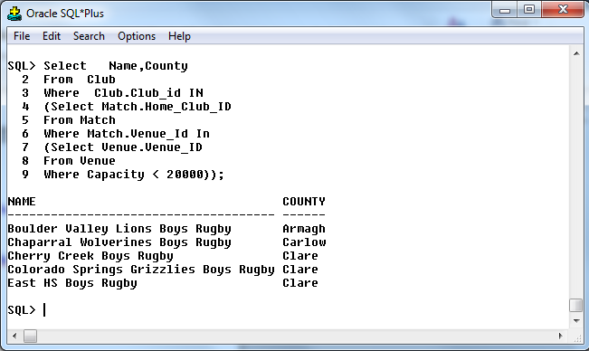

/* Q 8 FOR this query you may use the same 3 tables as you used in the previous query....but switch them around as explained in a couple of lines. Use of IN as a means of "linking" at least 3 diff tables in Main query and inner query - ie usually a situation involving a PK and an FK as the "linking" column. Eg 1- This time, the GRANDCHILD table will feature in the main (outer) query, the child table in the middle query, and the PARENT table at the innermost (deepest) level.
eg

Match_Id,Weather_Conditions,Attendance,Ticket_Price for those Weather_Conditions for a wet or dry which cost more than 40and involved a Match_Entertainer whose crowd reaction is good who was Entertainer in a Type in ‘group’.

Select Match_Id,Weather_Conditions,Attendance,Ticket_Price
From Match
Where Ticket_Price >40
And Weather_Conditions In (‘wet’, ‘dry’)
And Match.Match_Id In
(Select Match_Entertainer.Match_Id
From Match_Entertainer
Where Crowd_Reaction = ‘Good’
And Match_Entertainer.Entertainer_ID In
(Select Entertainer.Entertainer_ID
From Entertainer
Where Type =’Group’));

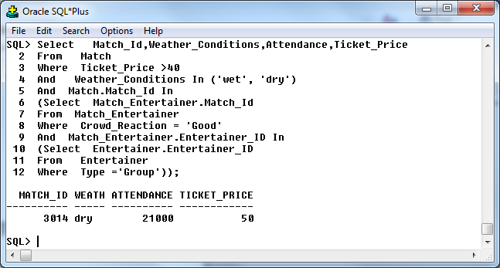

Note: In order to fully understand the above query, it’s a big help if you already understand JOINS (especially Parent Child Queries (PCQ). Notice that the PK = FK links are utilised in some subqueries in a manner similar to joins. Each link above is made by checking if a FK has a matching PK. The above query could also have been solved as a PCQ. Try to write the query above as a join so that you can check your own answer.

/* Q 9 IN - Write a query that displays some columns from just ONE table but which requires access to all of your tables - Then "solve" the same query using a join of all your tables. Eg Give the Name and salary of those employees who generated individual orders worth 1000 euro or more from customers who have creditlimits above 6000.
Hint for previous query - ie the "OUTER"/Main query displays data from just one table but "INNER" query requires several other tables in the exercise to be joined using a regular PCQ (PK = FK). In example on left, the columns displayed are all from the emp table but the customer and ord tables must both be accessed to help with the generation of the results. */

Select Match_Id,Weather_Conditions,Attendance,Ticket_Price
From Match
Where Ticket_Price >40
And Weather_Conditions In (‘wet’, ‘dry’,’snow’)
And Match.Match_Id In
(Select Match_Entertainer.Match_Id
From Match_Entertainer
Where Crowd_Reaction In (‘Good’,’Poor’)
And Match_Entertainer.Entertainer_ID In
(Select Entertainer.Entertainer_ID
From Entertainer
Where Type =’Group’))
And Match.Venue_id In
(Select Venue.Venue_ID
From Venue
Where Town In (‘Birr’,’Kells’))
And Match.Home_Club_ID In
(Select Club.Club_ID
From Club
Where Club_ID >1001);

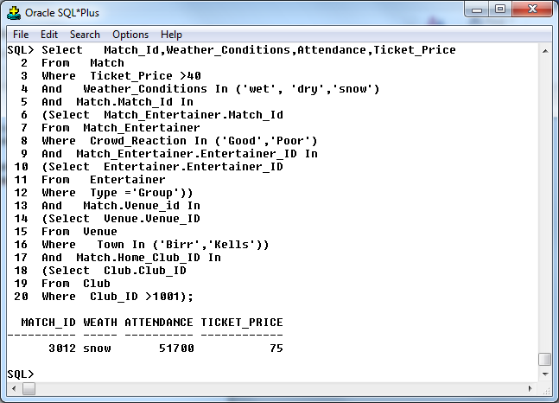

/* Q 10 NOT IN - query that uses at least 2 related tables - ie PK + FK links. */
List the name and County,Code,Club_id that county who are in ‘clare’ but who haven’t taken any Weather_Conditions that were wet or dry */

Select Name,County,Code,Club_id
From Club
Where County =’Clare’
And Club.Club_id Not In
(Select Match.Home_Club_ID
From Match
Where Weather_Conditions In (‘wet’, ‘dry’));

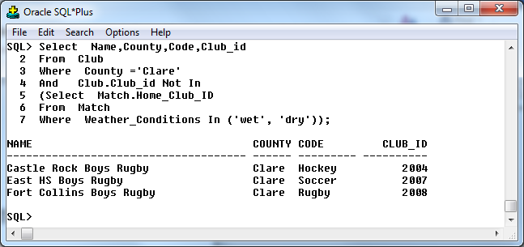

/* Q 11 ANY (demonstrate either > ANY or < ANY in a subquery).
List the Course Date, Title and Type and Couse of the workshop (type) dentist training courses with a course fee that exceeds the course fee for at least one of the dentist training courses that is classified as practical .1*/

Select Name,County,Code,Club_id
From Club
Where County =’Clare’
And Club.Club_id > All
(Select Match.Home_Club_ID
From Match
Where Weather_Conditions In (‘wet’, ‘dry’));

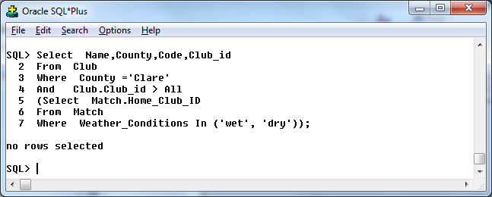

/* Q 12 ALL (demonstrate either > ALL or < ALL in a subquery).

List the Course Date, Title and Type and Couse of the workshop (type) dentist training courses with a course fee that exceeds the course fee for at least one of the dentist training courses that is classified as practical*/

Select Match_Id,Weather_Conditions,Attendance
From Match
Where Weather_Conditions = ‘wet’
And Attendance<ALL
(Select Max(Attendance)
From Match
Where Weather_Conditions = ‘dry’);

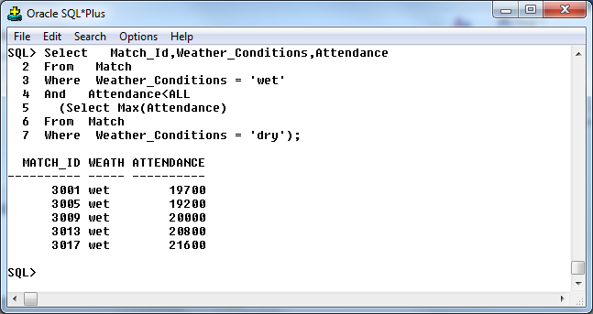

SPOOL OFF

13. Updates, inserts and deletes

-- Big Match Entertainment-BME – Niall Maher Year: 2012-2013

Big Match Entertainment-BME-Section 5 Oracle Projects - Inserts, Updates, Deletes

Spool C:\Clear\IUD.txt

/* DELETES
Q1 Failed DELETE due to integrity constraint eg attempt to delete parent who has children.-Ensure that the FKs are set up properly in the child table before the attempted delete. Demonstrate that Oracle works in "RESTRICT" mode and prevents removal of Parent if the Parent has children!!*/

Select Venue_ID,Name,Town
From Venue
Where Town = ‘Birr’;

Delete
From Venue
Where Town = ‘Birr’;

Rollback;

Select Venue_ID,Name,Town
From Venue
Where Town = ‘Birr’;

Rollback;

Select Venue_ID,Name,Town
From Venue
Where Town = ‘Birr’;
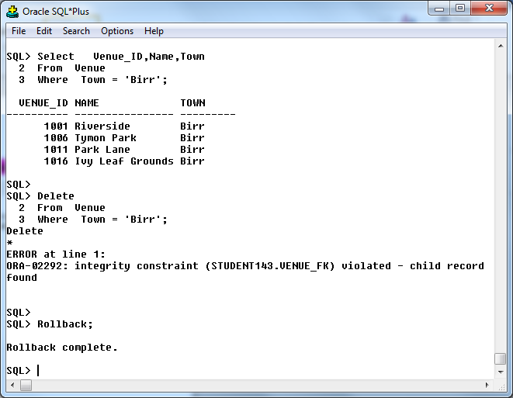

/* Q2 Successful delete that REQUIRES a subquery - ie Attempt to delete a Parent that doesn’t have children - again the PK and FK will be used to "link" the 2 parts of the query - ie the Main query has parent table in FROM clause and Inner query has child table in FROM clause. Key point is that the query will access at least 2 tables! (ROLLBACK after testing) */

Select Venue_ID,Name,Town
From Venue
Where Town <> ‘Birr’
And Venue.Venue_ID IN
(Select Match.Venue_id
From Match);

Delete
From Venue
Where Town <> ‘Birr’
And Venue.Venue_ID IN
(Select Match.Venue_id
From Match);

Rollback;

Select Venue,Name,Town
From Venue
Where Town <> ‘Birr’
And Venue.Venue_ID IN
(Select Match.Venue_id
From Match);

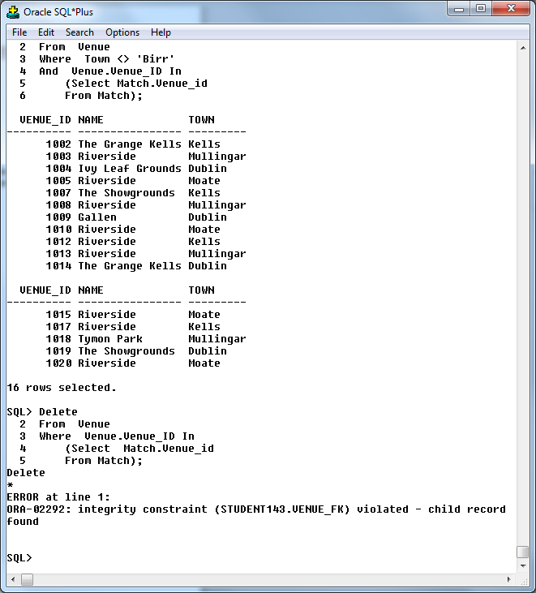

/* Q3 Delete from a grandchild table based on guidance from the grandparent - eg Remove the orders that are placed by customers that are assigned to employees that earn below 1550. This subquery requires three levels of nesting. ROLLBACK after testing. */

Select Venue_ID,Name,Town
From Venue
Where Venue.Venue_ID Not In
(Select Match.Venue_id
From Match
Where Match.Home_Club_ID In
(Select Club.Club_Id
From Club
Where Total_Members <40));
Delete
From Venue
Where Venue.Venue_ID Not In
(Select Match.Venue_id
From Match
Where Match.Home_Club_ID In
(Select Club.Club_Id
From Club
Where Total_Members <40));

Select Venue,Name,Town
From Venue
Where Venue.Venue_ID Not In
(Slect Match.Venue_id
From Match
Where Match.Home_Club_ID In
(Select Club.Club_Id
From Club
Where Total_Members <40));
Rollback;

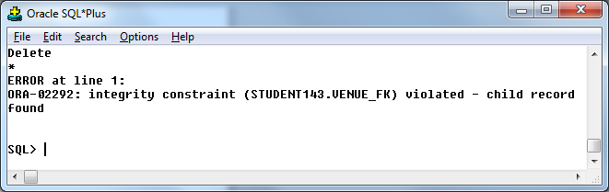

/* 4 Delete involving 2 tables (P+Child) that requires the use of IN as the "link" between the main query and the subquery. For this to work the ON DELETE CASCADE feature must be implemented in the FK constraint.

Remove those clinics based in Bundoran and their related appointments.

Note: The existing constraints in DDA operate in “RESTRICT” mode ie can’t delete a parent if the parent has matching children. Need to remove the existing foreign key constraints and replace them with foreign key constraints that contain the ON DELETE CASCADE rule. */

Q4.
Alter Table Match
Drop Constraint Match1_Fk;
Alter Table Match
Drop Constraint Match2_Fk;
Alter Table Match
Drop Constraint Venue_Fk;

Alter Table Match_Entertainer
Drop Constraint M_Entertainer1_Fk;
Alter Table Match_Entertainer
Drop Constraint M_Entertainer2_Fk;

Alter Table Match_Sponsor
Drop Constraint M_Sponsor1_Fk;
Alter Table Match_Sponsor
Drop Constraint M_sponsor2_Fk;

Alter Table Match
Add Constraint Match1_Fk Foreign Key (Home_Club_ID) References Club(Club_Id) On delete cascade;
Alter Table Match
Add Constraint Match2_Fk Foreign Key (Away_Club_ID) References Club(Club_Id) On delete cascade;
Alter Table Match
Add Constraint Venue_Fk Foreign Key(Venue_ID)References Venue(Venue_ID) On delete cascade;

Alter Table Match_Entertainer
Add Constraint M_Entertainer1_Fk Foreign Key(Match_Id) References Match(Match_Id) On delete cascade;
Alter Table Match_Entertainer
Add Constraint M_Entertainer2_Fk Foreign Key(Entertainer_ID) References Entertainer(Entertainer_ID) On delete cascade;

Alter Table Match_Sponsor
Add Constraint M_Sponsor1_Fk Foreign Key(Match_Id) References Match(Match_Id) On delete cascade;
Alter Table Match_Sponsor
Add Constraint M_sponsor2_Fk Foreign Key(Sponsor_Id) References Sponsor(Sponsor_Id) On delete cascade;

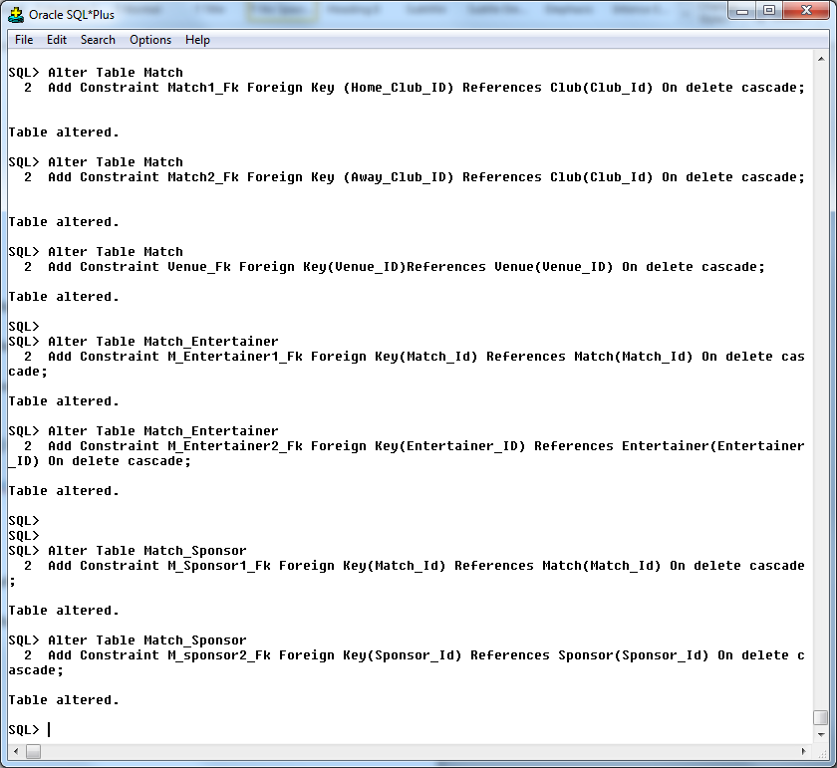

Q4.
Select Club_id,code,Town
From Club
Where Club.club_id In
(Select Match.Home_Club_id
From Match);
Delete
From Club
Where Club.club_id In
(Select Match.Home_Club_id
From Match);
Rollback;

Select Club_id,code,Town
From Club
Where Club.club_id In
(Select Match.Home_Club_id
From Match);
Rollback;
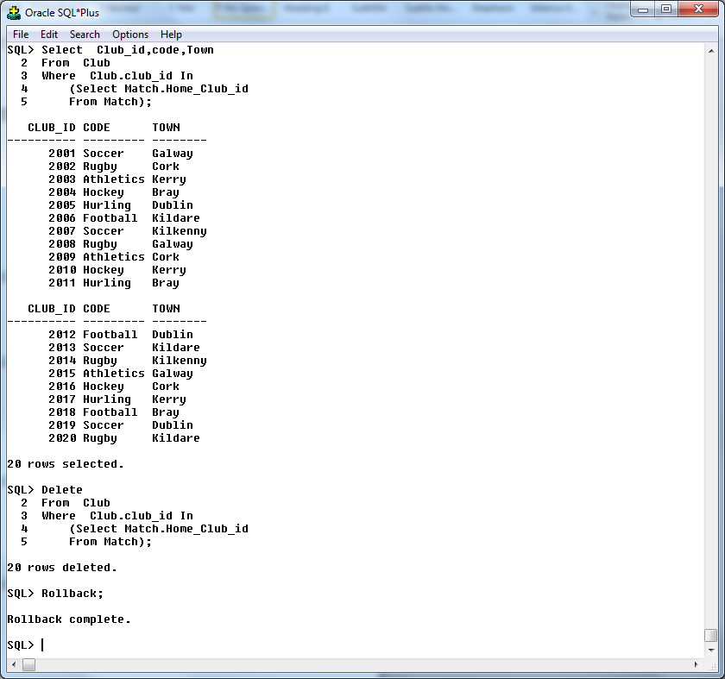

/*INSERTS*/
/* Q5 INSERT where columns are specified - ie you name the columns in the insert statement - see demobld7 for examples - don’t have the columns in the same order as in the create table statement - eg insert into Emp (Job, Sal, Empno, Ename,) values ( 'CLERK', 2400, 3241 ,'Dillon') - ROLLBACK when finished. */

Insert into Club(Club_ID,Code,Email)
values (2022,'Soccer',’Fuckingshit@hotmail.com');

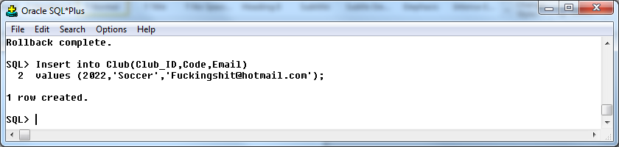

/* Q6 INSERT where a column in the table is specified and is deliberately set to NULL using NULL ie use the word NULL in the syntax
Insert into Venue values (1122, 'Daly’, Null, Null, ‘Clerk’,10); - You may use the same INSERT as the previous query - just edit it so that it suits this example - ROLLBACK when finished. */

Insert into Venue
Values (1111,'Bluehill','900 Newpark Road','Kill','Offaly','353-120-15455','jimhill.galway@gaa.ie',80000,1941,2040,'no');

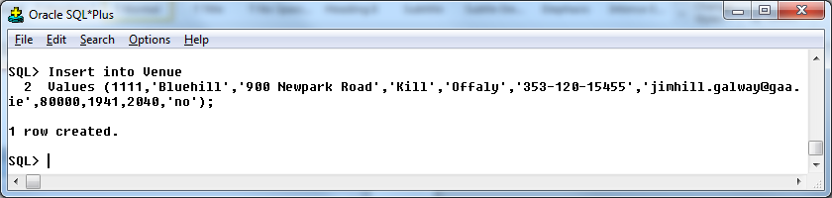

/* Q7 Insert that attempts to violate a FK-insert child for which there is no matching parent-eg Add an employee to the EMP table but attempt to assign the employee to Dept 80-this should fail as no such deptno exists in the Dept table-afterwards run another insert that corrects the attempted violation. */

Insert into Match(Match_id,Weather_Conditions,Attendance)
values (3021,'Frost',50000);
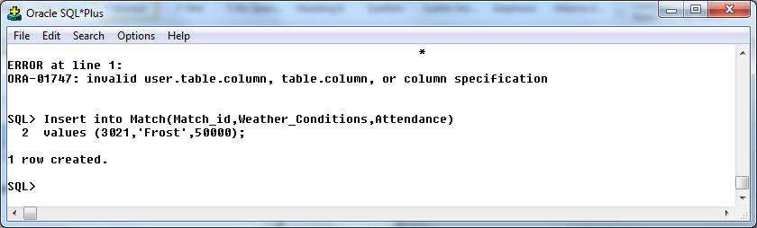

/*UPDATES*/
/* Q8 Failed UPDATE - eg update child FK to a new value, knowing that a matching parent doesn’t exist - eg in Emp and Dept, what should happen if an attempt was made to transfer the clerks to Dept 80? Then "fix" the update eg transfer an employee from one department to another -eg move an employee from dept 10 to dept 20. */

Select *
From Venue
Where Venue_ID = 1009;

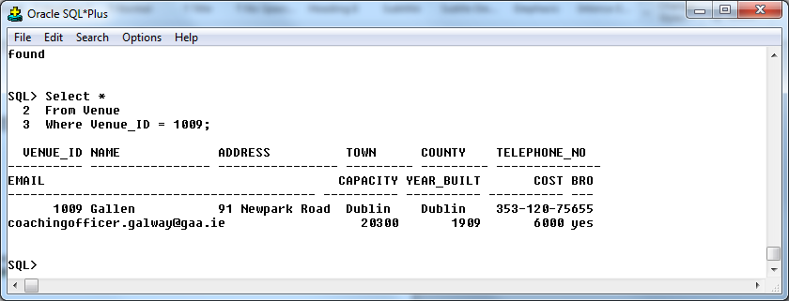

Update Venue
Set Venue_ID = 1030
Where Venue_ID = 1009;

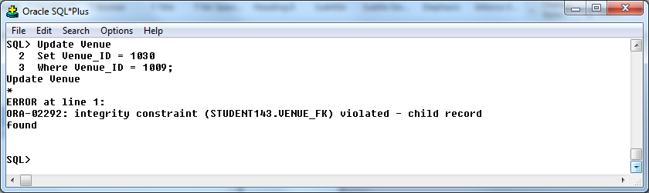

/* Q9 Attempt to Update a PK for a parent that has children ie prove that Oracle SQL doesn’t allow a cascade update - eg in dept table attempt to renumber dept 10 to 110.*/

Select *
From Match
Where Venue_ID = 1009;

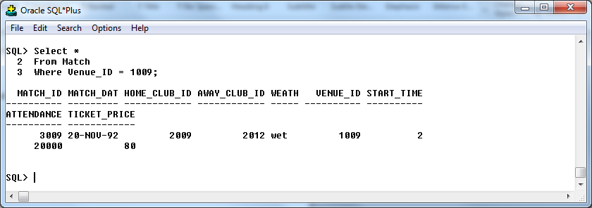

Update Match
Set Venue_ID = 1030
Where Venue_ID = 1009;

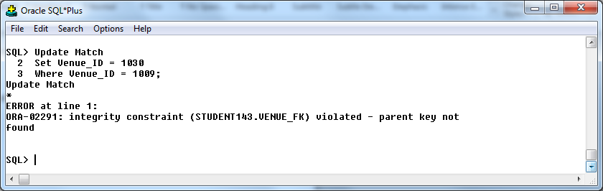

Rollback;

Spool Off

14. Views

-- Big Match Entertainment-BME – Niall Maher Year: 2012-2013

Big Match Entertainment-BME-Section 6 Oracle Projects - Views

Spool C:\Clear\Views.txt

/* Q1 create a vertical view - use 5 the cols in the table - ensure there are at least 3 conditions in the where clause (In, Like, Between)*/

Drop view V_River_Birr_Cap_Broad;
Create view V_River_Birr_Cap_Broad As
Select Name,Town,Broadband,Capacity
From Venue
Where Capacity >20000
And Broadband = ‘yes’
And Town in (‘Birr’, ‘Kells’, ‘Moate’)
And Address <> ‘Riverside’
Order by Name Desc;

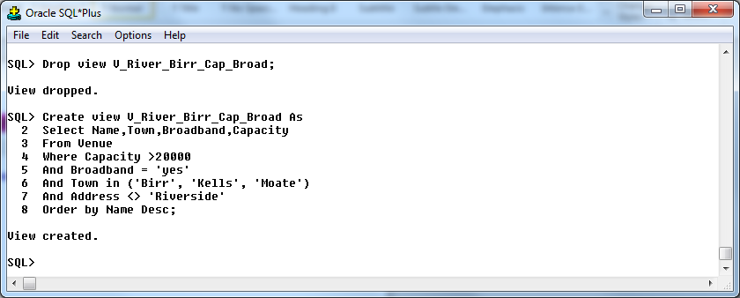

/* Q2 create a horizontal view - use the same table as previous query - use all the cols in the table - include calculated cols in the view definition - eg sal * 12 and ensure there are at least 2 conditions in the where clause*/

Drop View Venue_Capacity;
Create View Venue_Capacity As
Select Venue_Id,Capacity ,Capacity*12 “cap inc*12”,Town,Broadband
From Venue
Where Broadband = ‘no’
And Town Not in (‘Birr’, ‘Kells’, ‘Moate’)
Order by Town Desc;

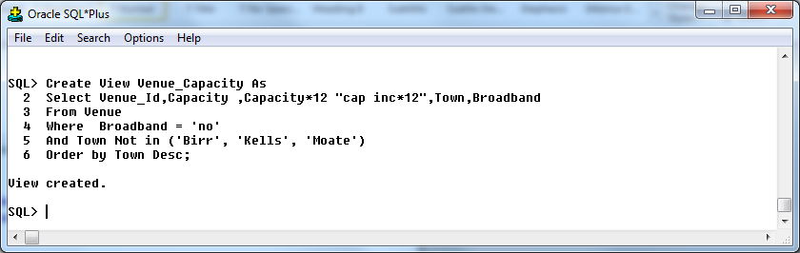

/* Q3 create view based on a join of at least 3 tables -egParent,Child,Grandchild tables should all feature in view-select clause should have at least 2 cols from both parent and child tables, and at least 3 from Grandchild. */

Set linesize 200
Drop View Club_Match_Match_Entertainer;
Create View Club_Match_Match_Entertainer As
Select Name,Town,Match.Match_Id,Match_Date,Stage,Performance_Length
From Club,Match,Match_Entertainer
Where Club.Club_ID = Match.Home_Club_ID
And Match.Match_ID = Match_Entertainer.Match_ID
And Town In (‘Cork’, ‘Dublin’, ‘Kerry’)
And Name <> ‘Aurora Saracens Boys Rugby’
And Match.Match_ID <3013
And Stage <>‘Before ’
And Performance_Length >40
Order by Name Desc;

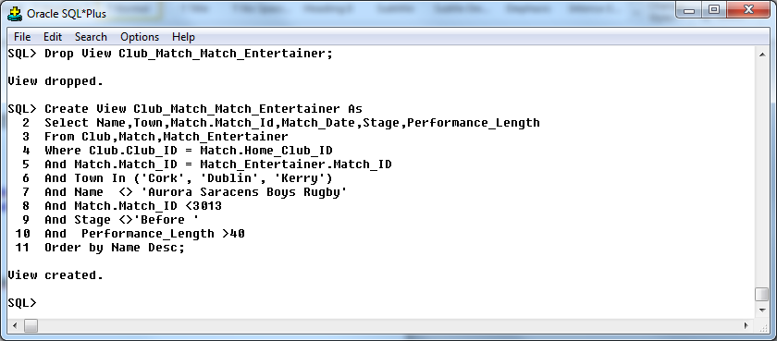

/* Q4 create view based on either a subquery or a summary query (Group By) - eg a view showing max(sal), min (sal), max(sal) - min(sal) for each job category. */

Drop View Cost_max_min_avg_count;
Create View Cost_max_min_avg_count As
Select Min(V.Cost)min,Max(V.Cost)max,Sum(V.Cost)sum,Avg(V.Cost)avg,Count(V.Cost)count
From Venue V;

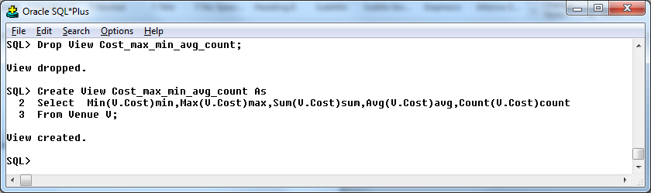

/* Q5 Create a view based on a SINGLE TABLE that doesn’t have a WITH CHECK OPTION clause (see next query so that you can plan ahead) - there should be at least 3 conditions in the "where" clause - make sure that the where clause has the effect of reducing the number of rows returned when the VIEW is queried! Then insert some rows that comply with where clause AND then some that don’t. */

Drop View Venue_Details;
Create View Venue_Details As
Select Venue_ID,Name,Address, County,Town,Capacity,Cost,Broadband
From Venue
Where Town <> ‘Dublin ’
And Cost Between 4000 And 6000
And Capacity Not In (2000,30000,40000)
And Name Like ‘%e’;

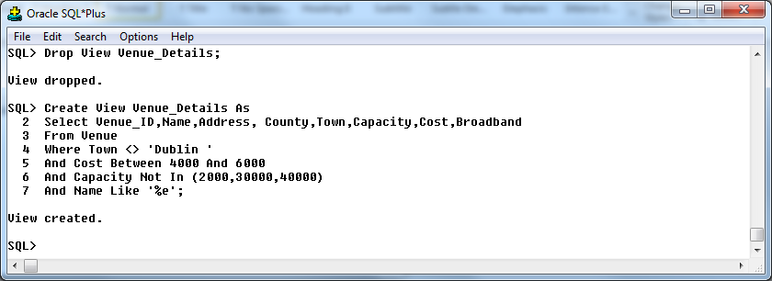

Select Count(*) From Venue;
Select Count(*)From Venue_Details;

Insert into Venue_Details values (1022,'Riverside','90 Newpark Road','Birr','Offaly',20000,1000,'yes');
Insert into Venue_Details values (1032,'Riverside','90 Newpark Road','Birr','Offaly',20000,2000,'yes');
Insert into Venue_Details values (1042,'Riverside','90 Newpark Road','Dublin ','Offaly',20000,2000,'yes');
select Count(*)From Venue;
Select Count(*)From Venue_Details;

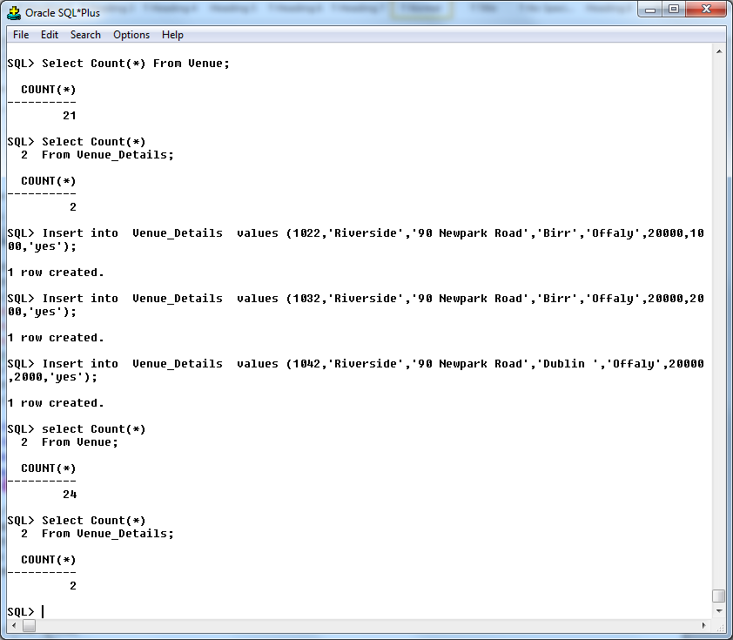

/* Q6 Create a view identical to the previous one but this time include a WITH CHECK OPTION clause - there should be at least 3 conditions in the where clause. Make sure that the WITH CHECK OPTION complements a CHECK constraint - ie does something a little bit extra. eg if theres a check constraint on the emp.job column for (Salesman, Manager, Analyst, Clerk, President), then a with check option shouldnt include all 5 options - just 2 or 3 of them at most. */

Drop View Venue_Details;
Create View Venue_Details As
Select Venue_ID,Name,Address, County,Town,Capacity,Cost,Broadband
From Venue
Where Town <> ‘Dublin ’
And Cost Between 4000 And 6000
And Capacity Not In (2000,30000,40000)
And Name Like ‘%e’
With check option;

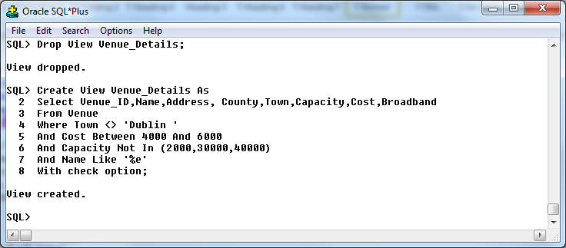

Select Count(*)
From Venue;
Select Count(*)
From Venue_Details;
Insert into Venue_Details values (1022,'Riverside','90 Newpark Road','Birr','Offaly',20000,1000,'yes');
Insert into Venue_Details values (1032,'Riverside','90 Newpark Road','Birr','Offaly',20000,2000,'yes');
Insert into Venue_Details values (1042,'Riverside','90 Newpark Road','Dublin ','Offaly',20000,2000,'yes');
Insert into Venue_Details values (1055,'Riverside','172 Mill House','Moate','Westmeath' ,19500, 4000,'yes');
Insert into Venue_Details values (1065,'Riverside','2 Mill House','Moate','Westmeath' ,19550, 4500,'yes');
Select Count(*)
From Venue;
Select Count(*)
From Venue_Details;
Rollback;

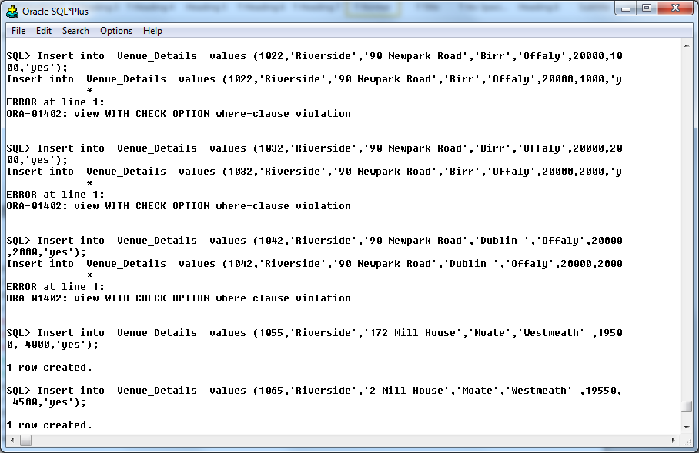

/* Q8 Attempt an Invalid Delete or an Invalid Update on a view containing a WITH CHECK OPTION clause - indicate the clause(s) in the conditions that causes the Delete to fail. Eg if theres a clause in the view definition that limits the view to clerks and analysts, then attempt to delete a manager. Then CORRECT the invalid DELETE/UPDATE - - then run it again to demonstrate that it succeeds. */

/* Invalid Update */

Update Venue_Details
Set Cost = Cost + 500
Where Town = ‘Dublin ‘
And Cost Between 4000 And 6000
And Capacity Not In (2000,30000,40000);

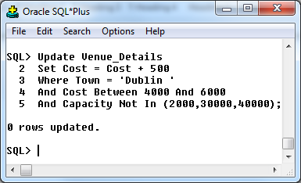

/* Valid Update */

Update Venue_Details
Set Cost = Cost + 500
Where Town != ‘Dublin ‘
And Cost Between 4000 And 6000
And Capacity Not In (2000,30000,40000);

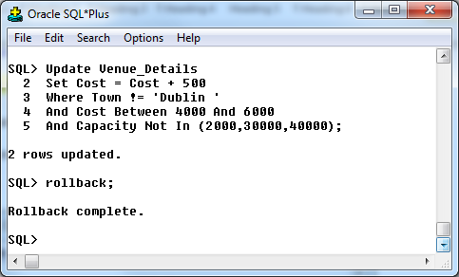

/* Invalid Delete */
/* Remove those patients from Letterkenny aged between 25 and 45 and currently earn 20000, 30000 or 40000. */

Select *
From Venue_Details
Where Town = ‘Dublin ‘
And Cost Between 4000 And 6000
And Capacity <20000;

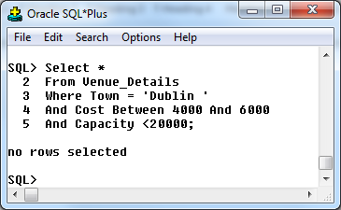

Delete
From Venue_Details
Where Town = ‘Dublin ‘
And Cost Between 4000 And 6000
And Capacity Not In (2000,30000,40000);

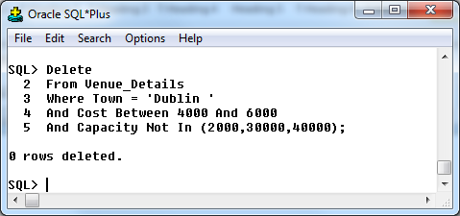

/* Valid Delete */
/* Remove those patients from Bundoran who are aged between 25 and 45 and currently earn 20000, 30000 or 40000. */

Select *
From Venue_Details
Where Town != ‘Dublin ‘
And Cost Between 4000 And 6000
And Capacity <20000;

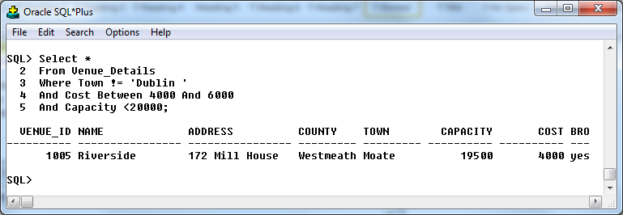

Delete
From Venue_Details
Where Town != ‘Dublin ‘
And Cost Between 4000 And 6000
And Capacity <20000;

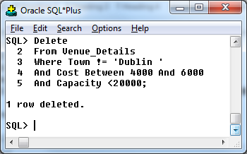

15. Security

-- Big Match Entertainment-BME – Niall Maher Year: 2012-2013

--Big Match Entertainment-BME 3 Oracle Projects - Privileges (SQL Security)

Spool C:\Clear\Privs.txt

/*Granting Priviliges on Tables */
/* 1. Grant any 3 of insert,update,delete on table1 to at least 2 of your classmates
Give student 90 and 91 the power to retrieve, remove and add new data to the Venue table. */

Grant Select,Update,Delete On Venue To Student90,Student91;

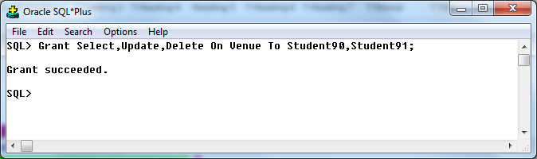

/* 2. grant select on a table2 to every current user in the database! Use keyword PUBLIC in the syntax
Give all users of the database the authority to retrieve data from the dentist table. */

Grant Select on Club To Public;

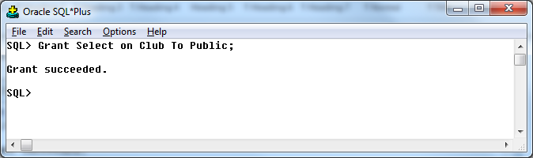

/* 3. Get classmate1 to include the WITH GRANT OPTION when he/she give you the select + 1 of IUD privs on one of his/her tables- then write a grant statement to pass the priv on to a 3rd classmate.
Student 93 has given me the power to retrieve and modify existing data in the sponsor table. I have been given the privilege to pass on this privileges to anyone I wish. I want to pass those privileges to student94. */

Grant Select,Update On Student143.SPONSOR To Student94;

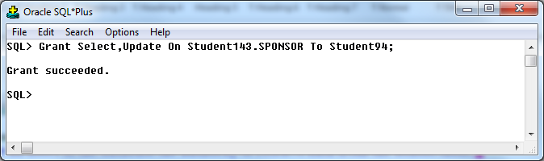

/* 4. Grant Select + one other privilege in addition to the With Grant Option to colleague1 on table1 - so that he/she can pass the privs to other students */
I want to give student95 the privilege to retrieve, and delete data from the Sponsor table and in turn pass on the privilege to whoever they wish. */

Grant Select,Delete On Sponsor To Student95 With Grant Option;

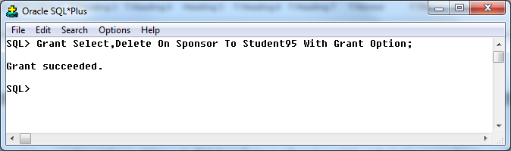

/*Granting Priviliges on Views*/
Advice: When giving priviliges on a view to colleagues, note that you should only give the priviliges that are appropriate for that type of view - eg there is no point giving the insert privilege on a view if the view doesn’t have the PK column, or columns with NOT Null constraints etc
/* 5 grant select, insert on a view1 to a single user - choose a view that contains all columns in a table */

I have created a view called V_River_Birr_Cap_Broad.Student96 needs to be able to have read level access on this data. */

Grant Select On V_River_Birr_Cap_Broad To Student96;

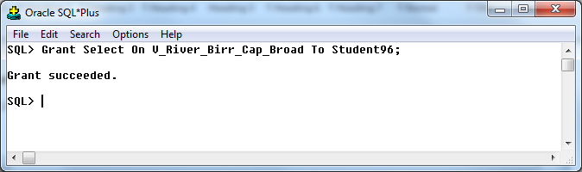

/* 6 grant update/delete on a view2 to at least two different colleagues - again - choose a view that contains all columns in a table */
I have created a view called Dentist_Training_Lecture (which shows all details for Dentist_Training that are of type Lecture). Student97 and Student98 need to be able to have modify and remove data from this view. */

Grant Select,Update,Delete On V_River_Birr_Cap_Broad To Student97,Student98;
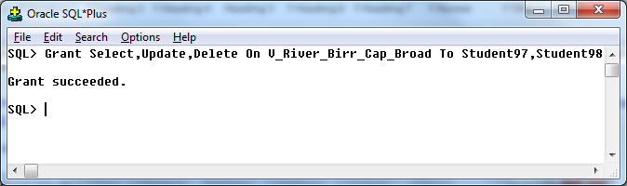

/*Priviliges Granted by Others to You*/
/* Assuming that you have recieved priviliges from your colleagues, then before you start devising queries for this section, please name each of the colleagues that is working with you, the tables involved and the privilige you have received on each table before you start this section - This will aid in clarification etc */

/* 7 Attempt a valid insert/update/delete on a table that you have insert priv for from colleague 1-rollback immediately afterwards
Assume that student99 has created a view called V_River_Birr_Cap_Broad .Student99 has given me the privilege to Add new rows, modify existing rows and remove rows when manipulating data with this view. */

Insert Into Student143 V_River_Birr_Cap_Broad values (1055,'Riverside','172 Mill House','Moate','Westmeath' ,19500, 4000,'yes');
Rollback;
Insert Into Student143 V_River_Birr_Cap_Broad values (1055,'Riverside','172 Mill House','Moate','Westmeath' ,21000, 4000,'No');
Rollback;

/*For those V_River_Birr_Cap_Broad ,increase the capacity by 5000 in each case. */

Select Name,Town,Broadband,Capacity
From Venue
Where Capacity >20000
And Broadband = ‘yes’
And Town in (‘Birr’, ‘Kells’, ‘Moate’)
And Address <> ‘Riverside’;

Update Student43. V_River_Birr_Cap_Broad
Set Capacity = Capacity + 5000
Where Town = ‘Birr’
And Capacity >= 19000;

Select Name,Town,Broadband,Capacity
From Venue
Where Capacity >20000
And Broadband = ‘yes’
And Town in (‘Birr’, ‘Kells’, ‘Moate’)
And Address <> ‘Riverside’;

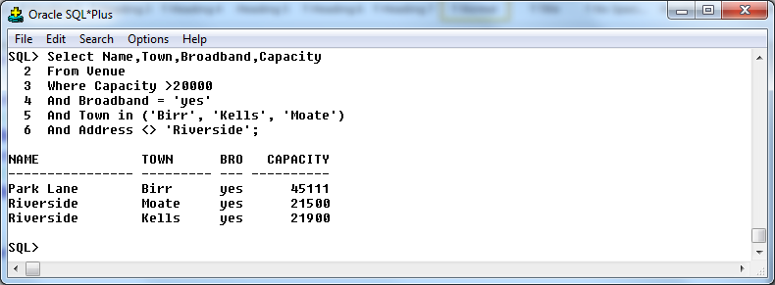

Rollback;

/*Valid Delete from Classmates (student99) view
Remove those Dentist_Training courses that were held in Dublin that cost 3000, are of type Practical and last for at least 3 days. */

Select Name,Town,Broadband,Capacity
From Venue
Where Capacity >20000
And Broadband = ‘yes’
And Town in (‘Birr’, ‘Kells’, ‘Moate’)
And Address <> ‘Riverside’;

Delete
From Student143. V_River_Birr_Cap_Broad
Where Capacity >12000;

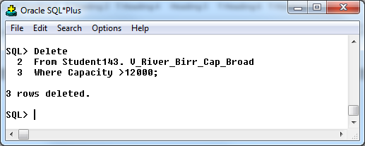

Rollback;

Select Name,Town,Broadband,Capacity
From Venue
Where Capacity >20000
And Broadband = ‘yes’
And Town in (‘Birr’, ‘Kells’, ‘Moate’)
And Address <> ‘Riverside’

/*Revoking Priviliges that have been given to other students */
/* 8 Revoke a single privilege on a table1 from colleague 1
In an earlier query, student95 was assigned the privilege to retrieve, and delete data from the clinic table and in turn pass on the privilege to whoever they wish. It has been decided that student95 no longer needs the power to delete data from the clinic table. */

Grant Select,Delete On Sponsor To Student95 With Grant Option;

Revoke Delete On Sponsor From Student95;

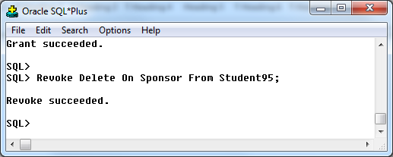

/* 9 Revoke at least two of (select,insert, update, delete) of the privileges from colleague 2 on a table2

In an earlier query, student90 was given the power to retrieve, remove and add new data to the patient table. It has been decided that student90 no longer needs the power to add new data to or to remove data from the patient table. */

Grant Select,Update,Delete On Venue To Student90,Student91;
Revoke Update,Delete On Venue From Student90;

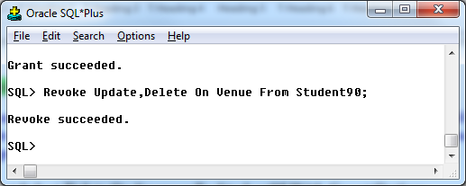

Spool Off

16. Ddl alter table statements

-- Big Match Entertainment – BME– Niall Maher HDip 2012-2013

Big Match Entertainment-BME-Section -Section 8 Oracle Projects - Alter Table

Spool C:\Clear\ ALTTAB.txt

/*Alter Table Statements */
/* 1 ALTER statement to add a column to a table- give column appropriate, name, data type and size. */
/*A Column to hold details of the web site of each course should be added to the course table. A web site will require a maximum of 20 characters. Make the relevant change to the database structure. */

Alter Table Match
Add Web_Site Varchar2 (20);
Describe Match;

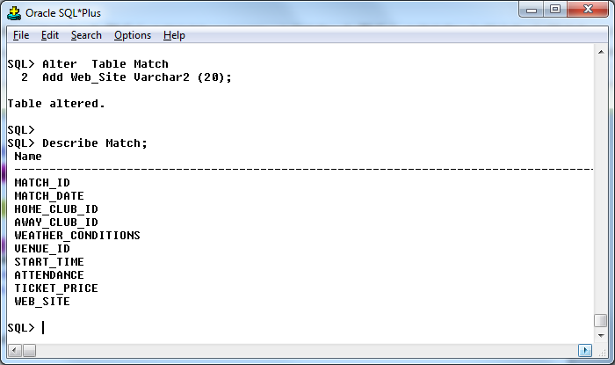

/* 2 ALTER statement to add a column with a CHECK constraint - ie add the column and the constraint with one ALTER table statement. */

/*A Column to hold details of the Assessment Method held at the end of a course should be added to the Course table. The possible values are Oral, Written, and MCQ. Make the relevant change to the database structure to fulfill this requirement. */

Alter Table Venue
Add Venue_Sponsor Varchar2 (7);

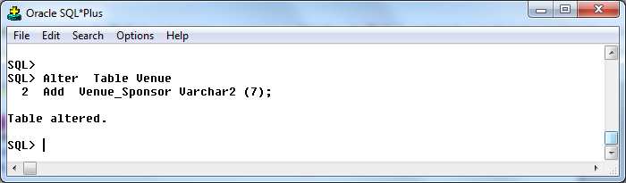

/*Examine theCorse Table to ensure that the new column as been added. */

Describe Venue;

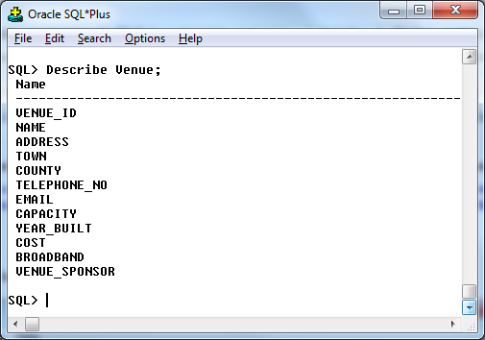

/*Examine the USER_CONSTRAINTS system table to ensure that the new constaint as been added. */

Select Table_Name, Constraint_Name, Constraint_Type, Status
From User_Constraints
Where Table_Name = ‘Match’;

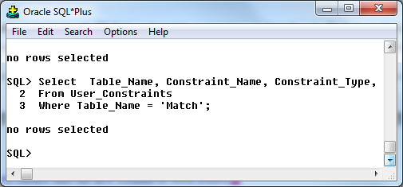

/* 3 ALTER statement to increase width of an existing column to accommodate larger values than originally anticipated - keyword MODIFY */

/*Increase the size of the web site column added earlier to the clinic table. A web site will require a maximum of 22 characters and not 20 as originally specified. Make the relevant change to the database structure. */

Alter Table Match_Sponsor
Modify Payment_Method Varchar2(8);

Describe Match_Sponsor;

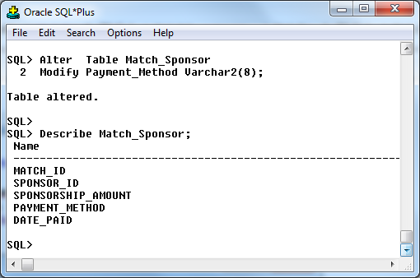

/* 4 Give the Syntax necessary to remove a column from a table-ie add a column and then drop the column immediately (don’t drop the table) */
/*A Column to hold details of the employer Email Address should be added to the Advisor table. An Email Address will require a maximum of 15 characters. Make the relevant change to the database structure to fulfill this requirement. Then, remove the Email Address column from the Employer table. */

Alter Table Club
Add Manager Varchar2(15);

Describe Club;

Alter Table Club
Drop Column Manager ;

Describe Club;

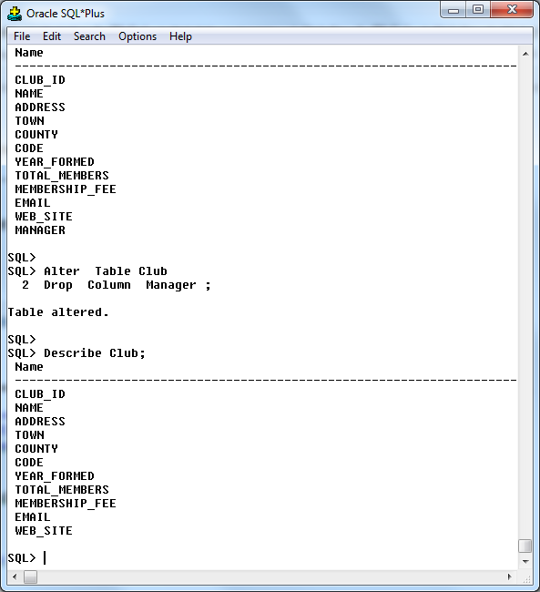

/* 5 Drop a PK constraint from a table using the ALTER command - attempt to violate the constraint before and after the ALTER - May need to rollback the violation, so be careful! Note that you will have to drop any matching FK before PK will drop. Query USER_CONSTRAINTS to verify the name of the constraint before doing the PK drop. */

/*Remove the primary key from the Dentist Training table. */

Select Table_Name, Constraint_ Name, Constraint_Type
From User_Constraints
Where Table_Name = ‘Club’;

/*Attempt an insert on the table - prove the PK is “working” ie insert the first row shown in the Venue table*/
insert into Consultation values (3001,'01/01/2010',30,'Course Job Prospects','Satisfied');
Note that the Name Of The Constraint is shorter and doesn’t conform with the normal rules recommended for naming constraints….the max no characters that may be in a constraint name is 30?????????
Alter Table Venue
Drop Constraint Venue_Id_PK;

/*Attempt the same insert on the table - prove the PK is NOT “working” ie insert the first row shown in the Venue table. */
insert into Consultation values (3001,'01/01/2010',30,'Course Job Prospects','Satisfied');

/* 6 Add a PK constraint to a table using the ALTER command- ie setup the PK that you dropped earlier. */

/*Add the primary key to the Venue table. */

Alter Table Venue
Add Constraint Venue_Id_PK Primary Key;

Select Table_Name, Constraint_ Name, Constraint_Type
From User_Constraints
Where Table_Name = ‘Venue’;

/* 7 Disable a PK constraint in a table and attempt an INSERT to duplicate a "PK" value - reverse (rollback) the change fairly fast!! Turn back on (Enable) the PK constraint that was turned off earlier-Does it succeed?? If it fails, check for Duplicate PK values */

/*Temporarily deactivate the primary key to the Patron table. */

Alter Table Match
Disable Constraint Match_Id_PK;

Insert into Match values values (3009,'20-Nov-92',2009,2012,'wet',1009,2.00,20000,80);

Rollback;

Alter Table Match
Add Constraint Match_Id_PK; Primary Key (Match_Id));

Select Table_Name, Constraint_Name, Constraint_Type
From User_Constraints
Where Table_Name = ‘Match’;

/* 8 Drop a FK constraint from a table using the ALTER command - then attemt to insert an "ORPHAN" - does insert succeed?? (Rollback the insert if it succeeded) - then Add a FK constraint to a table using the ALTER command - ie put back the constraint that was dropped in the previous example. */

/*Remove the FK linking the Match and Venue tables*/

Alter Table Match
Drop Constraint Match_ID_FK

Select Table_Name, Constraint_Name, Constraint_Type
From User_Constraints
Where Table_Name = ‘Match’;

/*Add 2 new Venue. Note that they have FK values (9007 and 9008) that don’t have matching PK values in the Match*/

Insert into Venue values (9007,Homeland','190 Dunluce Road','clara','Offaly','353-120-97655','mseery@killu.com',45111,1911,7000,'yes');
Insert into Venue values (9008,'Park Lane','200 Dunluce Road','Birr','Offaly','353-120-97655','mseery@killu.com',45111,1911,7880,'No');

Rollback;

Alter Table Venue
Add Constraint School_Patron_ID_FK Foreign Key (Patron_ID) References Patron (Patron_Id));

/* 9 Disable a FK constraint in a table and attempt to create an ORPHAN "FK" value - reverse the change fairly fast!! Otherwise trouble later! Turn back on (Enable) the FK constraint that was turned off earlier-Does it succeed?? If it fails, check for Orphans in the Child table - delete orphans and attempt to Enable afterwards */

/*Temporarily deactivate the FK linking the Match and Venue tables*/

Alter Table Match
Disable Constraint Match_ID_FK

Select Table_Name, Constraint_Name, Constraint_Type
From User_Constraints
Where Table_Name = ‘Match;

/*Add 2 new schools. Note that they have FK values (9007 and 9008) that don’t have matching PK values in the University*/

Insert into Venue values (9007,Homeland','190 Dunluce Road','clara','Offaly','353-120-97655','mseery@killu.com',45111,1911,7000,'yes');
Insert into Venue values (9008,'Park Lane','200 Dunluce Road','Birr','Offaly','353-120-97655','mseery@killu.com',45111,1911,7880,'No');

Rollback;

/* Reactivate the FK linking the School and Match tables*/

Alter Table Match
Enable Constraint Match_ID_FK

/* 10 Drop a CK constraint from a table using the ALTER command - attempt an insert/update that "conflicts" with the original check constraint definition-does the insert succeed/fail - rollback if necessary - Add a CK constraint to a table using the ALTER command - ie put back the constraint that was dropped earlier. */

/*First of all, get a list of the constraints on all tables */
Select Table_Name, Constraint_Name, Constraint_Type
From User_Constraints;

/*Next, get a list of the constraints on a specific table e.g. Match*/
Select Table_Name, Constraint_Name, Constraint_Type, Status
From User_Constraints
Where Table_Name = ‘Match’;

/*Then, identify a CK constraint that can be removed from the Match table. */
Alter Table Match
Drop Constraint Course_Cost_CK;

Select Table_Name, Constraint_Name, Constraint_Type, Status
From User_Constraints
Where Table_Name = ‘Match’;

Alter Table Match
Add Constraint Course_Type_CKCheck (Type In(‘Certificate’,’Ord Degree’,’Hons Degree’));

/* 11 Disable a NN constraint from a table using the ALTER command-- attempt an insert/update that "conflicts" with the original Not Null constraint definition-then attempt to Enable the NN constraint again-if this fails remove/change the violating row-and Enable the NN again. */

/*Deactivate the Not Null constraint associated with the Name column in the university table. */
Select Table_Name, Constraint_Name, Constraint_Type
From User_Constraints
Where Table_Name = ‘Club’;

Alter Table Dentist
Disable Constraint University_Name_NN;

Select Table_Name, Constraint_Name, Constraint_Type
From User_Constraints
Where Table_Name = ‘Club’;

/* 12 Drop a UQ or a NN constraint from a table using the ALTER command */

/*Remove the Unique constraint associated with the School phone number column in the School table.
Constraint School_Phone_Uq Unique (Phone_No) */

Select Table_Name, Constraint_Name, Constraint_Type
From User_Constraints
Where Table_Name = ‘Venue’;

Alter Table School
Drop Constraint School_Phone_Uq;

Select Table_Name, Constraint_Name, Constraint_Type
From User_Constraints
Where Table_Name = ‘Venue’;

SPOOL OFF
17. Transaction processing

-- Big Match Entertainment – BME– Niall Maher HDip 2012-2013

Big Match Entertainment-BME-Section -Section 9 Oracle Projects - Transaction Processing

Spool C:\Clear\ TP.txt

/*Demonstration of Locking in Oracle*/
Student60 S143.1
Student41 S143.2
Student49 S143.3
Changing Venue Capacity ,
Grant Select on Course to Public;
Grant Update on Course to Public;
Grant Update on Course (Capacity) to Student 143.2, Student143.3; */

EX1 | Session1 (client1) S143.1 | Session2 (client2) S143.2 | Session3 (client3) S143.3 | Observations
T 1 | Select Sum(Capacity)  From Student143.1Course; |  |  | SUM(Capacity) 50000  All users select executed with no delay. Shared lock.
T 2 | Update Student143.1Course  Set Capacity=Capacity+500; |  |  | *  ERROR at line 1:  ORA-01031: insufficient privileges
T 3 | Select Sum(Capacity)  From Student143.1Course; |  |  | SUM(CAPACITY) 50000
T 4 |  | Update Student143.2Course  Set Capacity=Capacity+100  Where Duration =1; |  | S141.2runs update.  Uncommitted updates of concurrent actions are invisible to other users.  S49 got an exclusive lock.
T 5 | Update Student141.1Course  Set Capacity=Capacity*500; |  |  | SUM(CAPACITY) 50000  Uncommitted updates of concurrent actions are invisible to other users.
T 6 |  |  | Update Student141.3Course  Set Capacity=Capacity+500  Where Duration =1; | S143.3 runs update  This is been delayed / blocked because S143.2update has not been committed or rollback.  S143.2 had an exclusive block in place.
T 7 | Select Sum(Capacity)  From Student143.1.Course; |  |  | SUM(CAPACITY) 50000
T 8 |  | Committed | Released | S143.2 Commit updates
T9 | Select Sum(Capacity)  From Student141.1.Course; |  |  | SUM(CAPACITY) 50700  S143.1 Committed updates are visible
T10 | Select Sum(Capacity)  From Student143.1.Course; |  | Commit | SUM(CAPACITY) 54200

OBSERVATION: Uncommitted updates are invisible to others clients. Only committed transactions are visible.
SPOOL OFF

18.Systems catalog(system tables-data dictionary)

-- Big Match Entertainment – BME – Niall Maher -HDip 2012-2013

--Big Match Entertainment-BME-Section 10 Oracle Projects - System Catalog-

Spool C:\Clear\DD.txt

/* Q1 Give the constraint names and type of each constraint on the Match_Sponsor table. */
Select Constraint_Name, Table_Name, Constraint_Type
From User_Constraints
Where Table_Name = ‘Course;

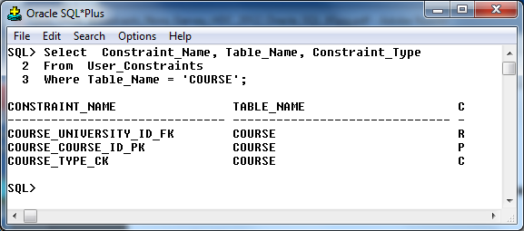

/* Q2 Show how many constraints that are on each of the tables. */

Select Table_Name, Count(*)
From User_Constraints
Group by Table_Name;
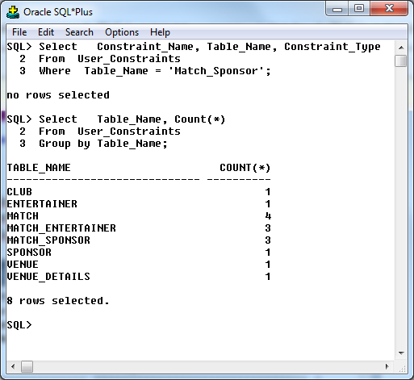

/* Q3 Give the name of each view that I have built. */

Describe User_Views;
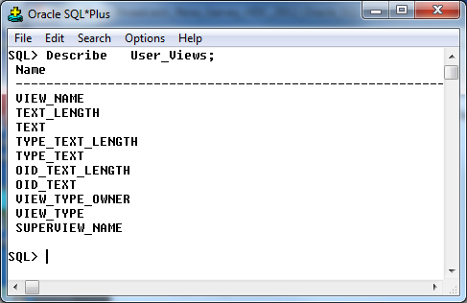

/* Q4 Give the name of each constraint that I have built. */

Describe User_Constraints;

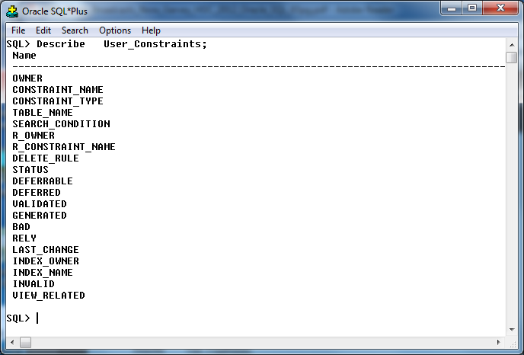

/* Q5 Give the name of all the constraints that I have access to. */
Describe All_Constraints;

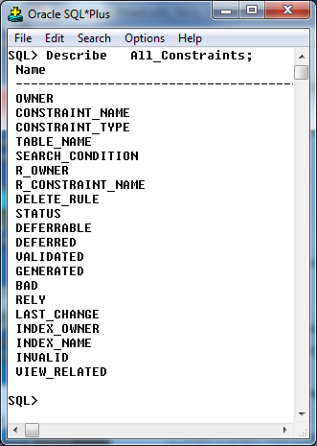

/* Q6 Assume A student called Student51 gives you privilages to a table called Vehicle which they built. Show all info about that table. */

Describe Student51.Vehucle;

SPOOL OFF

